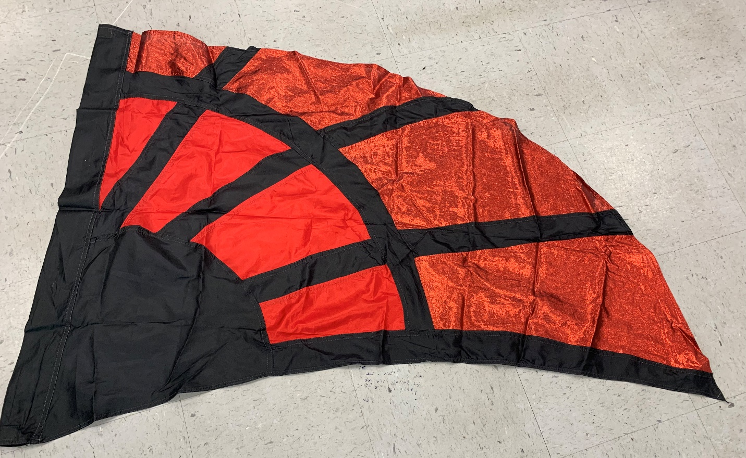
Red and black spider flag (21 flags – 36”x52”) $10 each

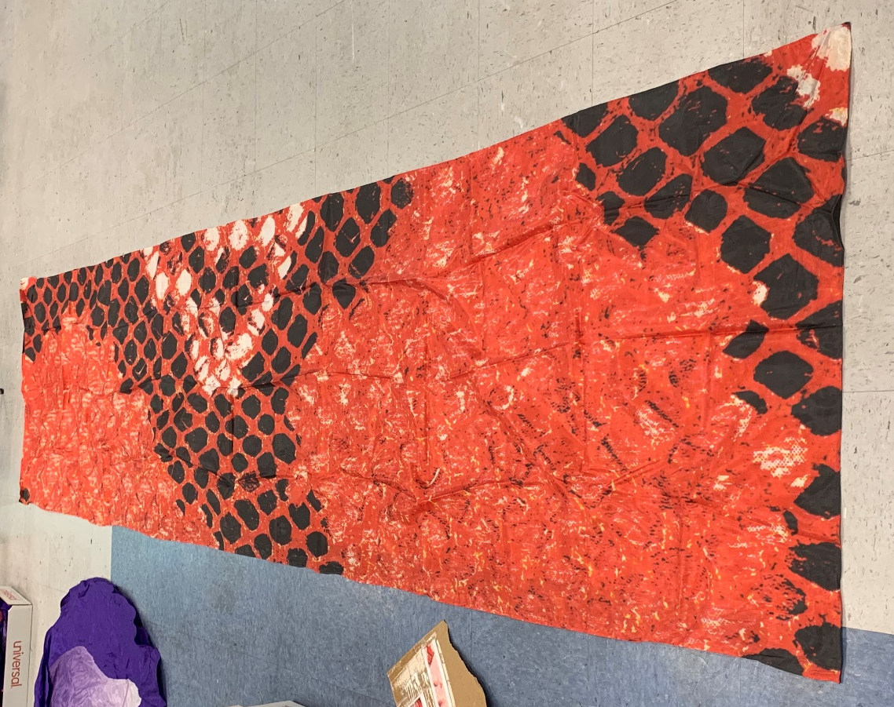
Rectangular extended snake skin flag – red/black (23 flags – 35”x140”) $25 each

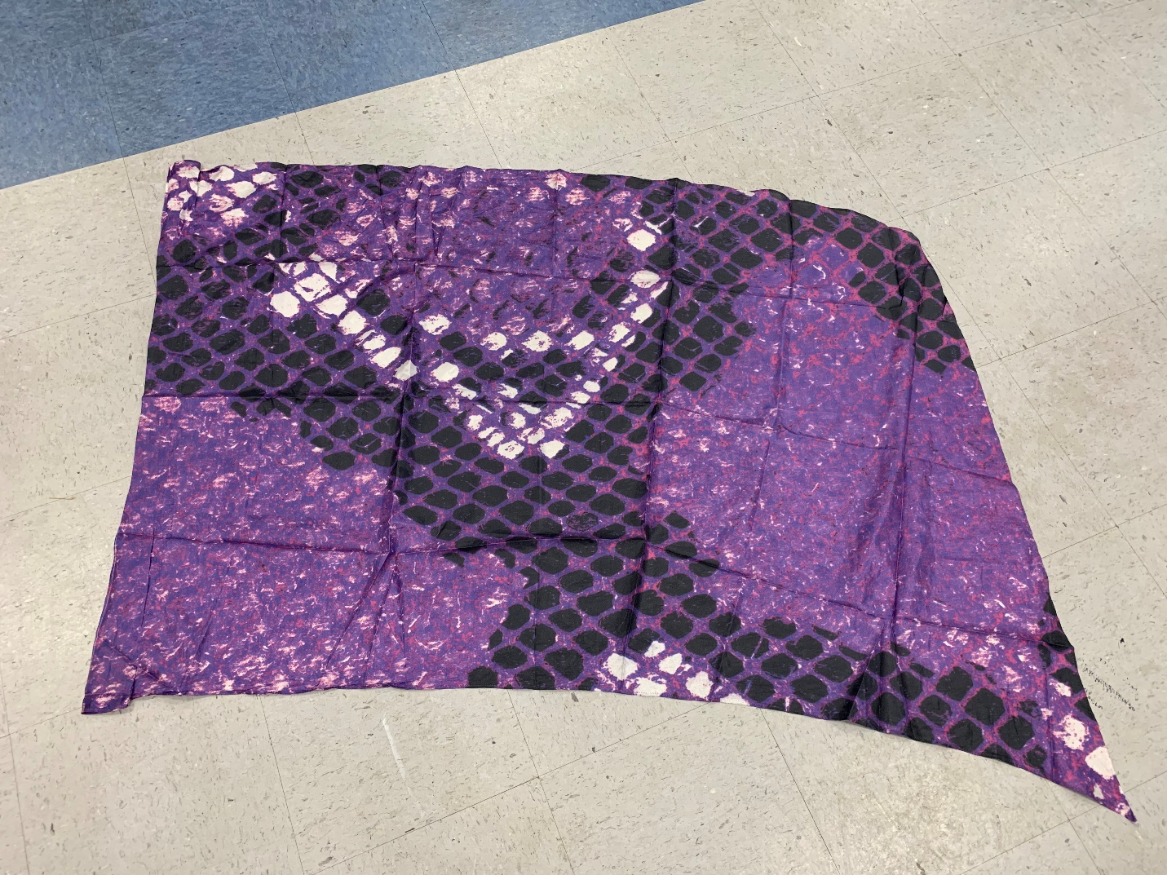
Purple snake skin flag (32 flags – 36”x52”) $15 each

Green snake skin flag (32 flags – 36”x52”) $15 each

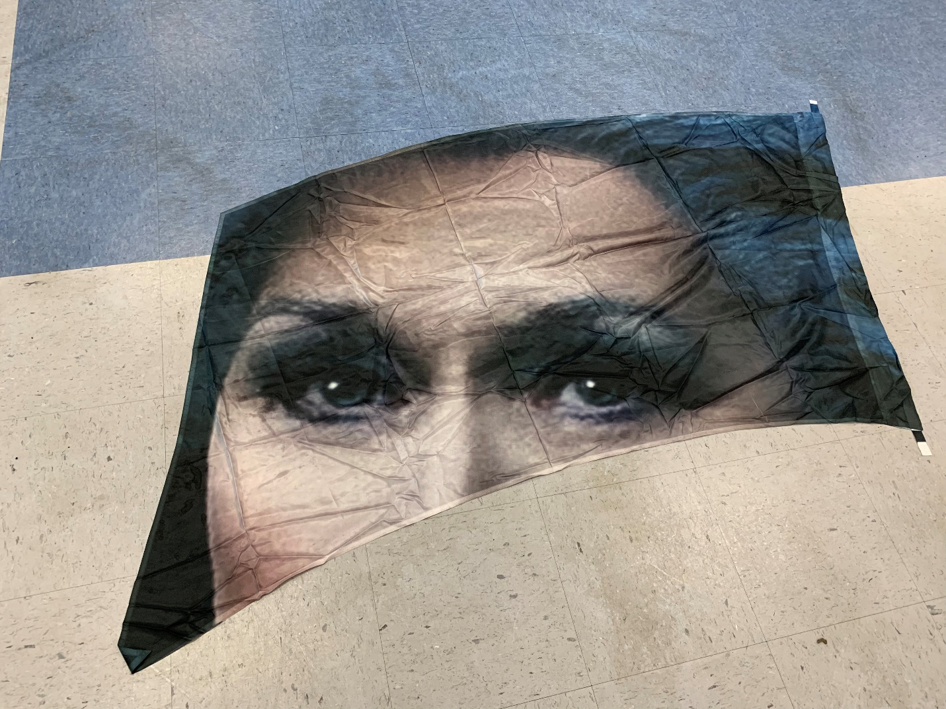
Witch – Into the Woods flag (21 flags – 36”x77”) $25 each

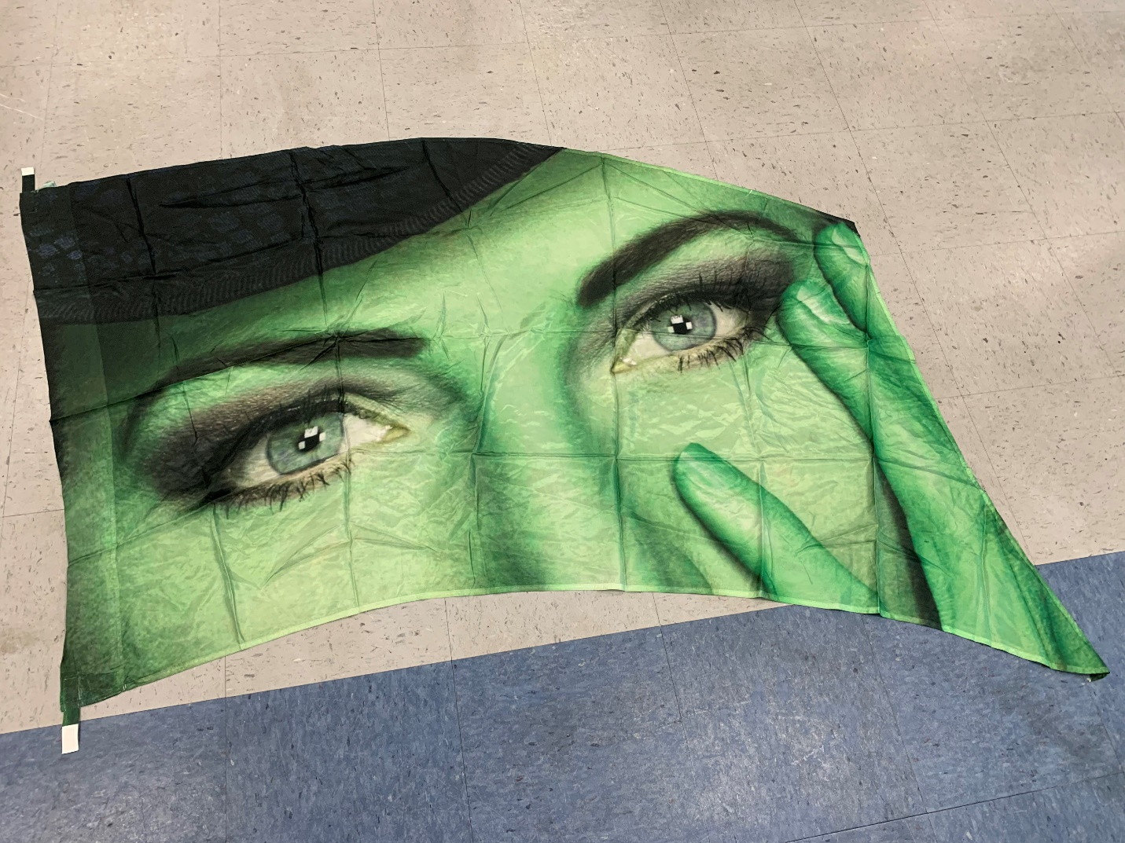
Witch – Wicked flag (27 flags – 36”x77”) $25 each

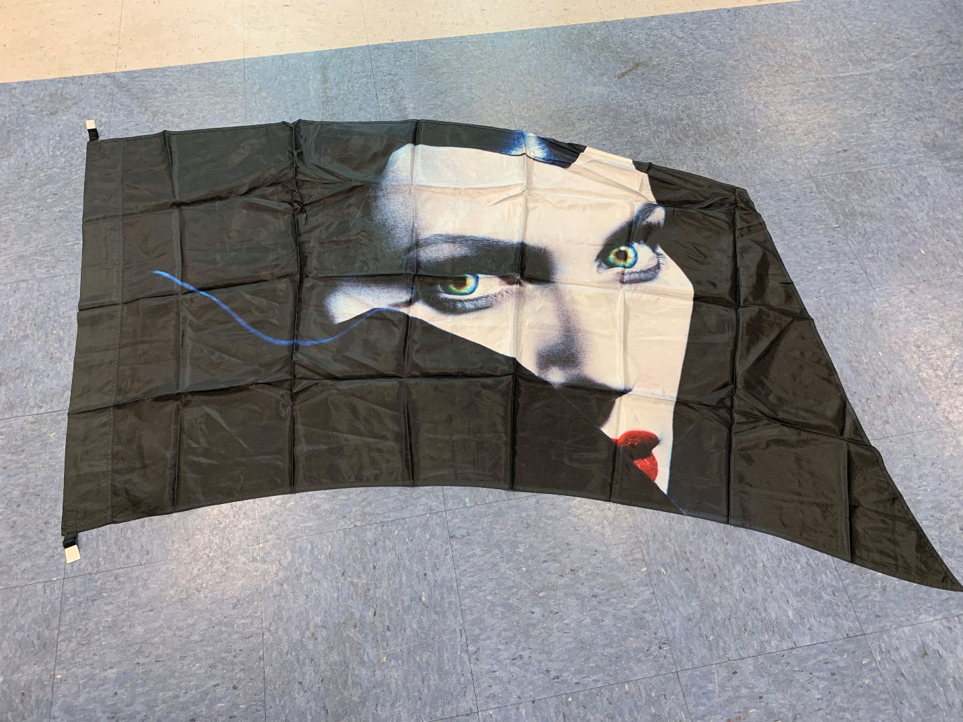
Witch – Maleficent flag (37 flags – 36”x77”) $25 each

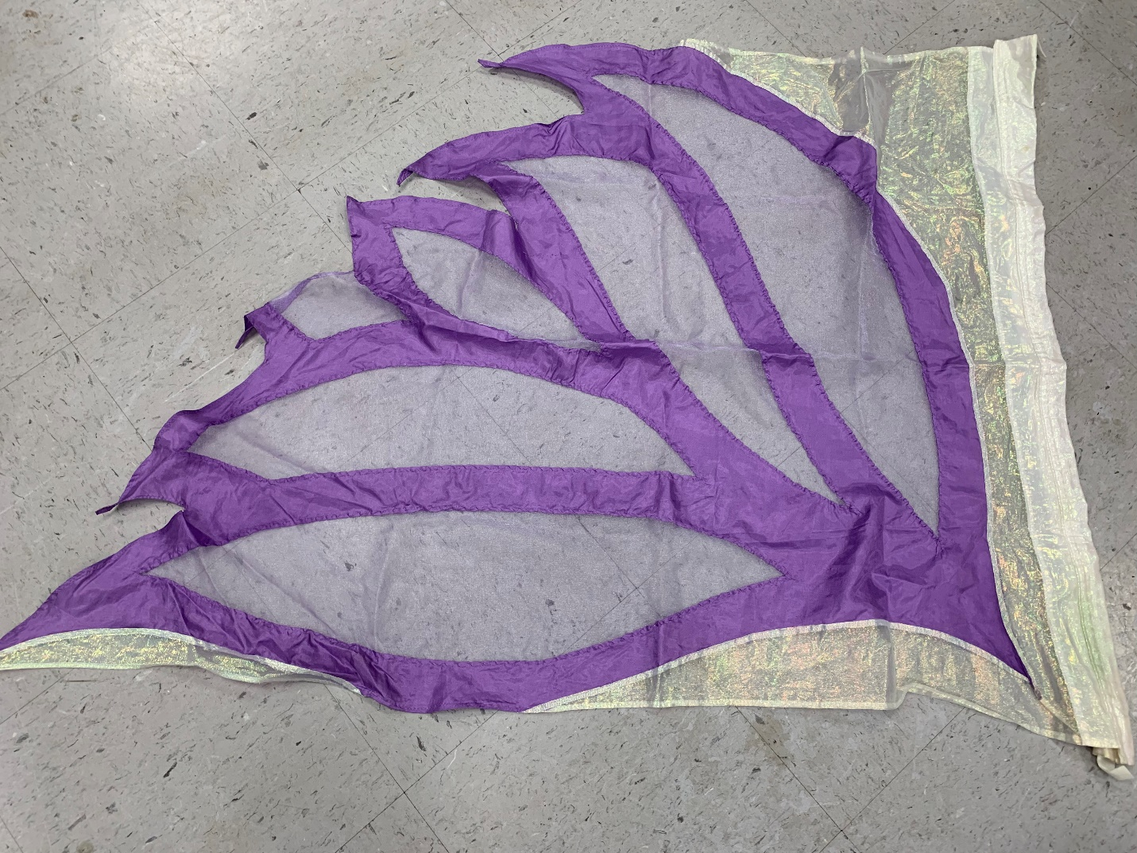
Lilac butterfly swing flags (11 flags) $5 each

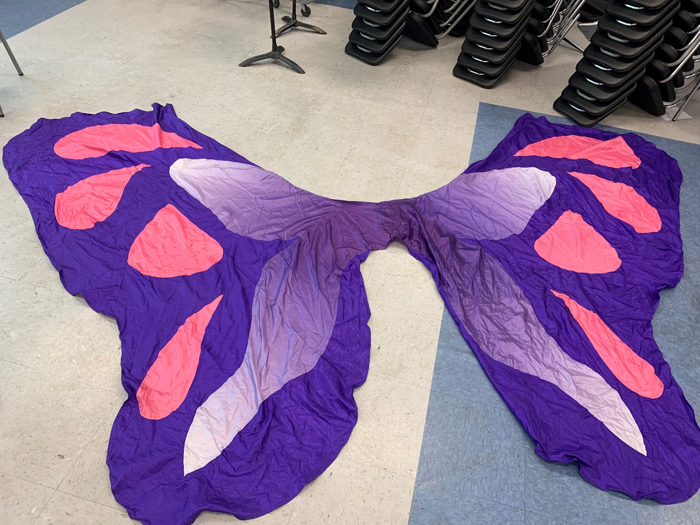
Full butterfly (11 flags – 38” on the pole, 72’ length, 66” width) $15 each

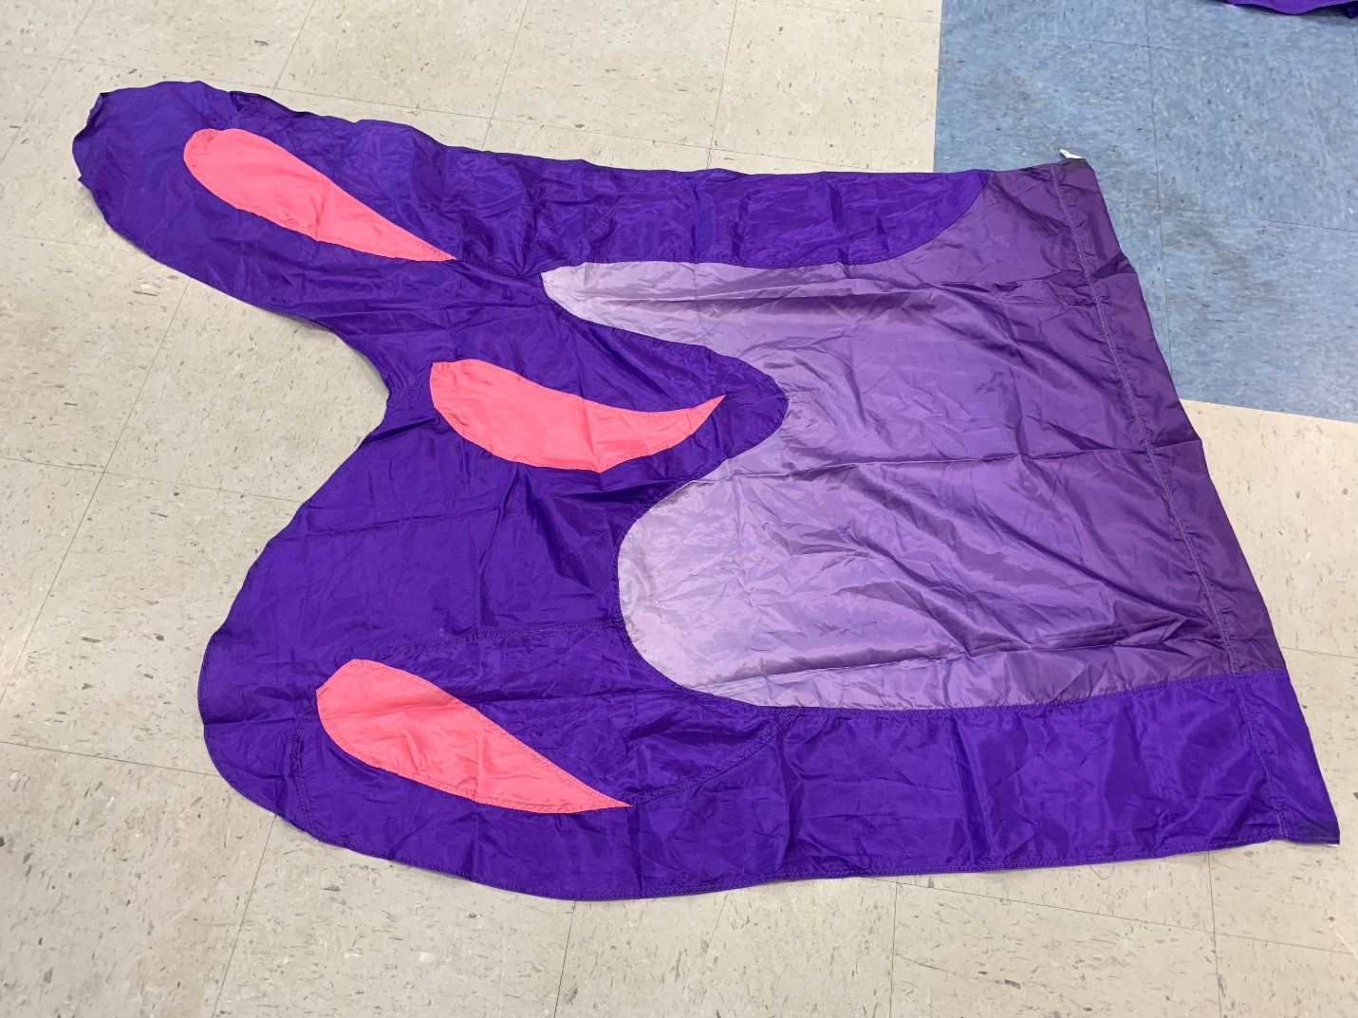
Butterfly wing flag (9 flags – 35”x69”) $10 each

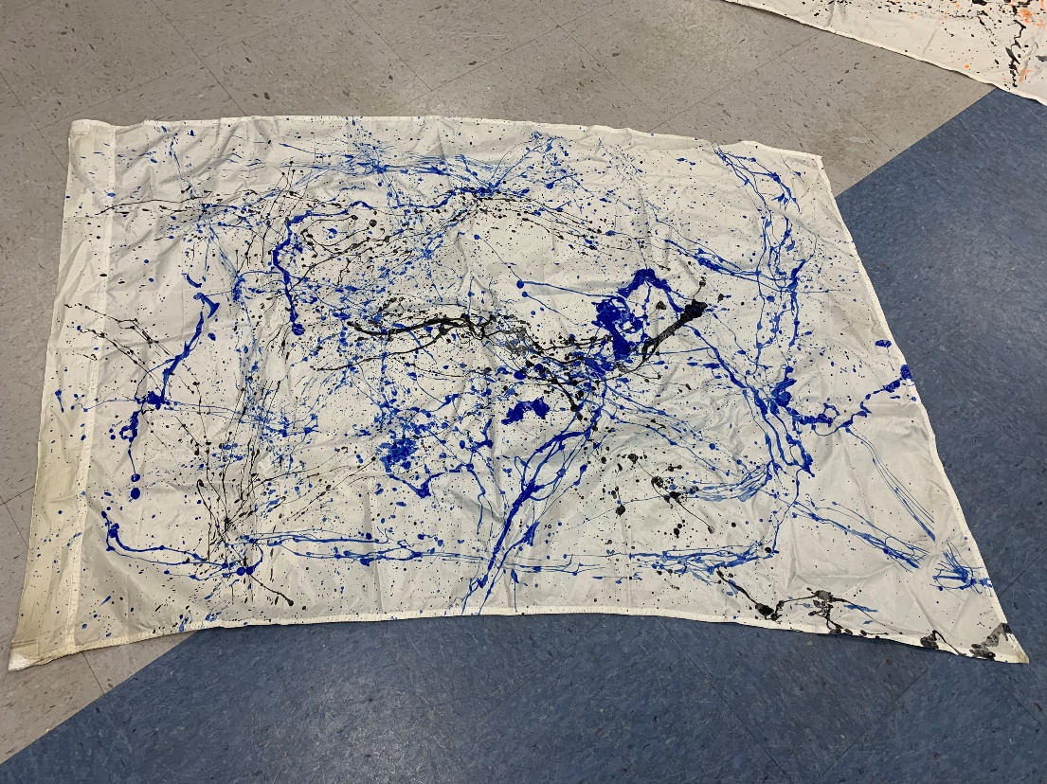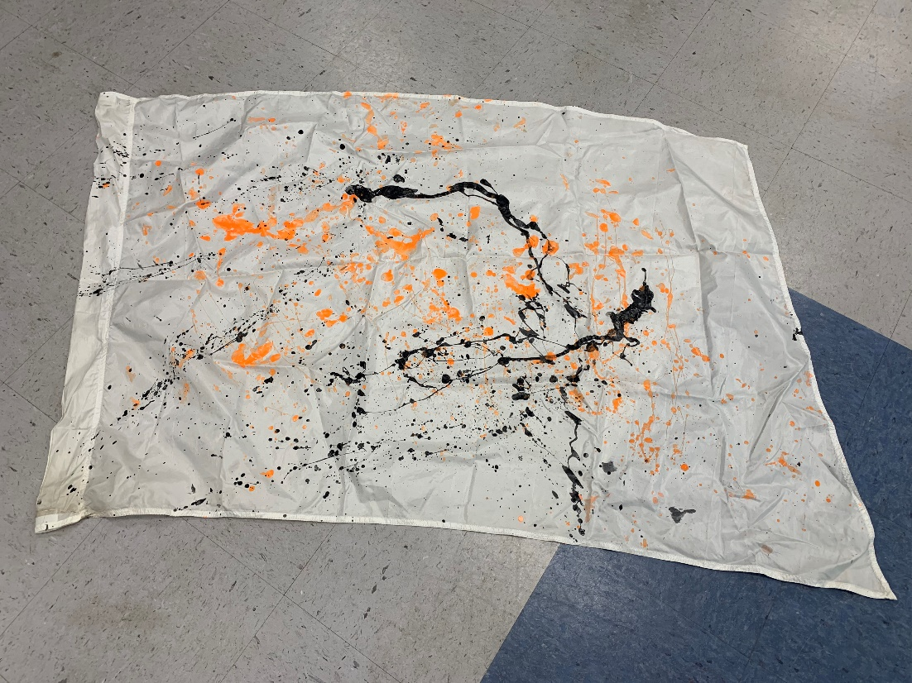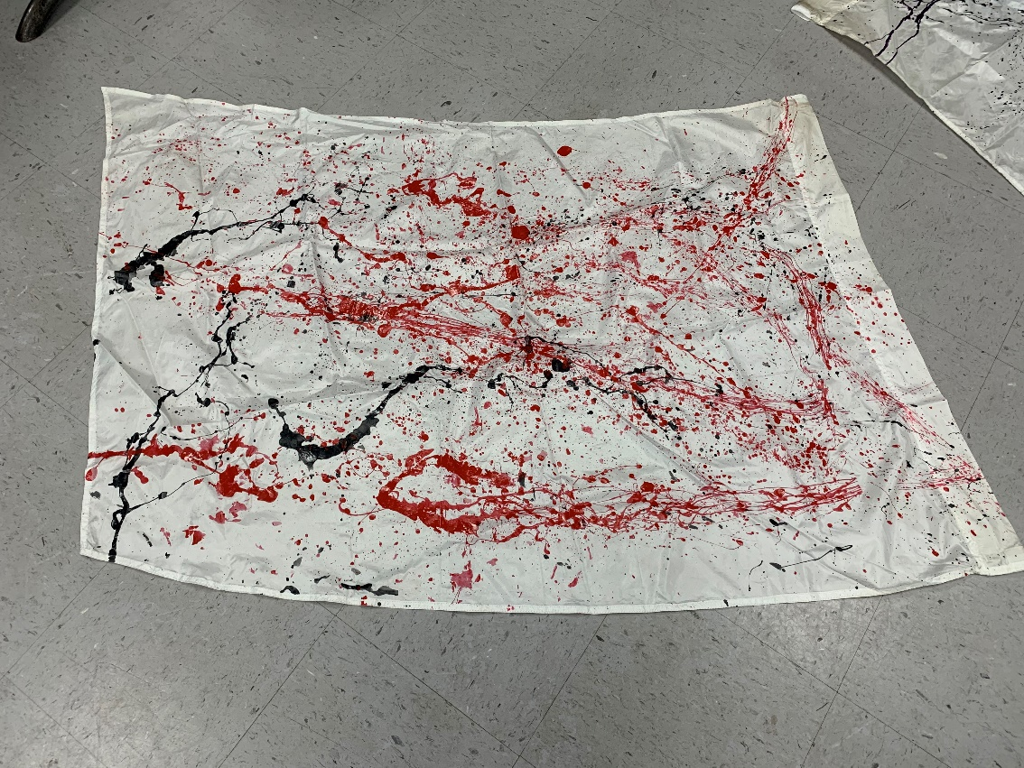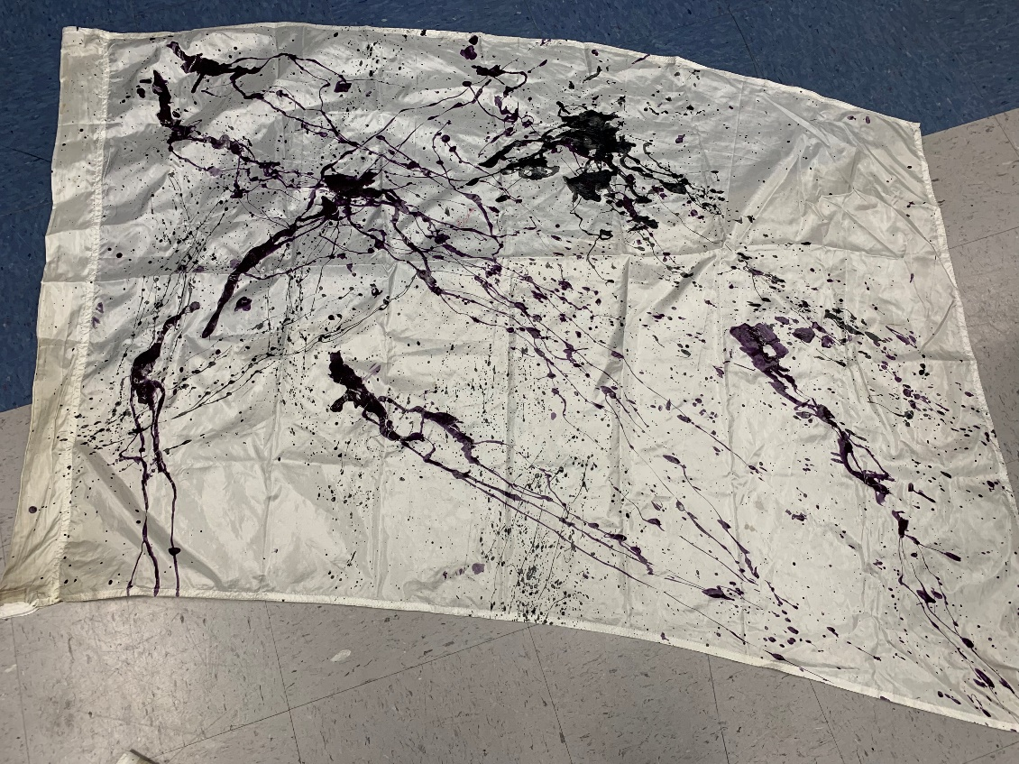
Splatter flags $5 each
Blue (9 flags – 36”x52”)
Orange (3 flags – 36”x52”)
Red (6 flags – 36”x52”)
Purple (6 flags – 36”x52”)

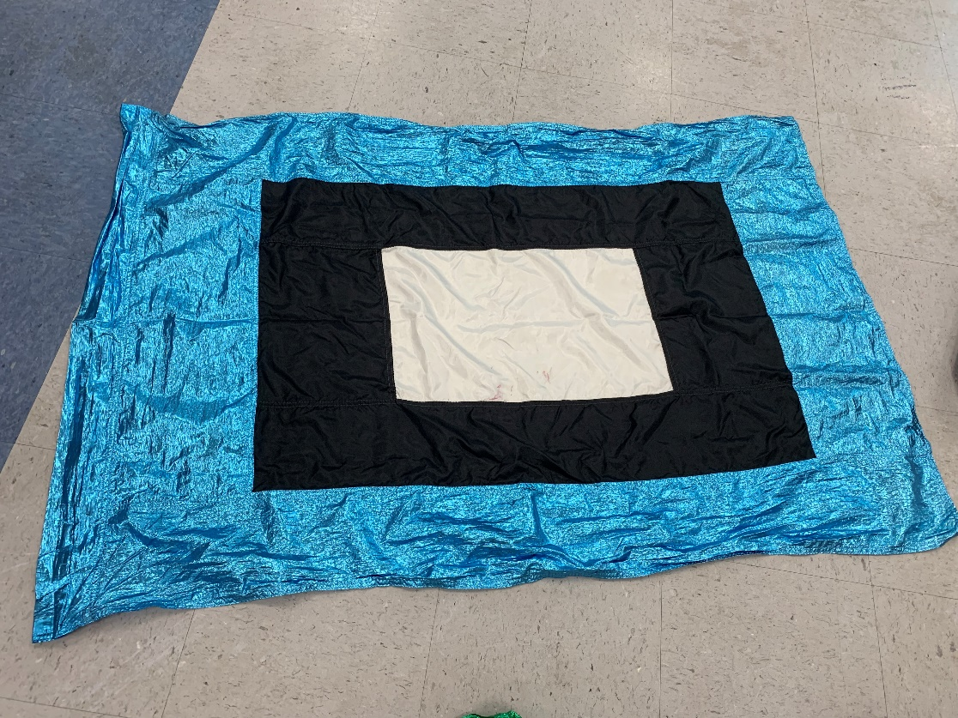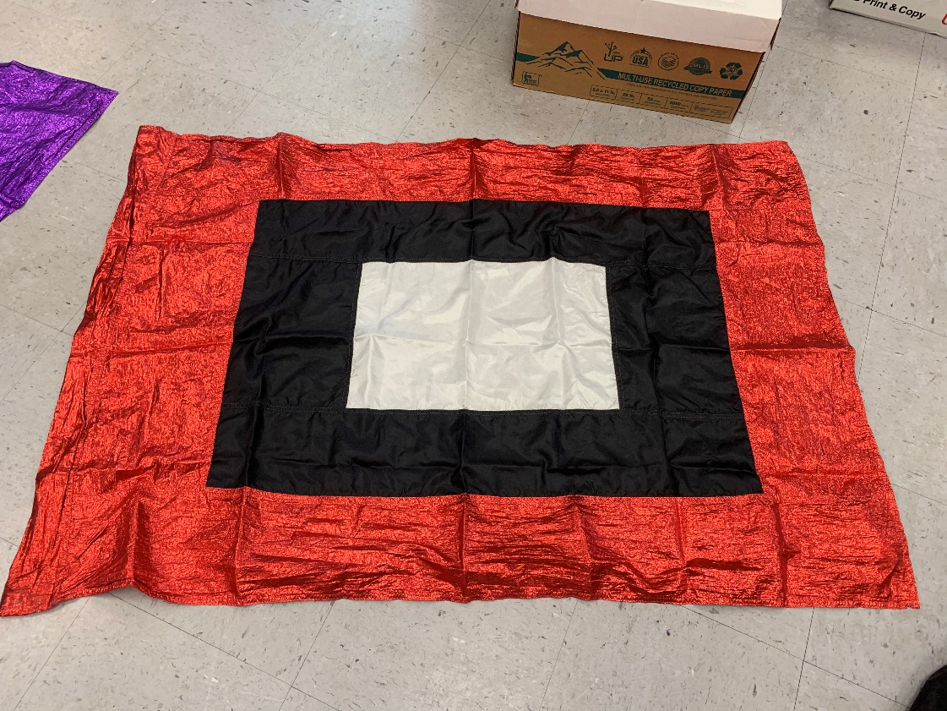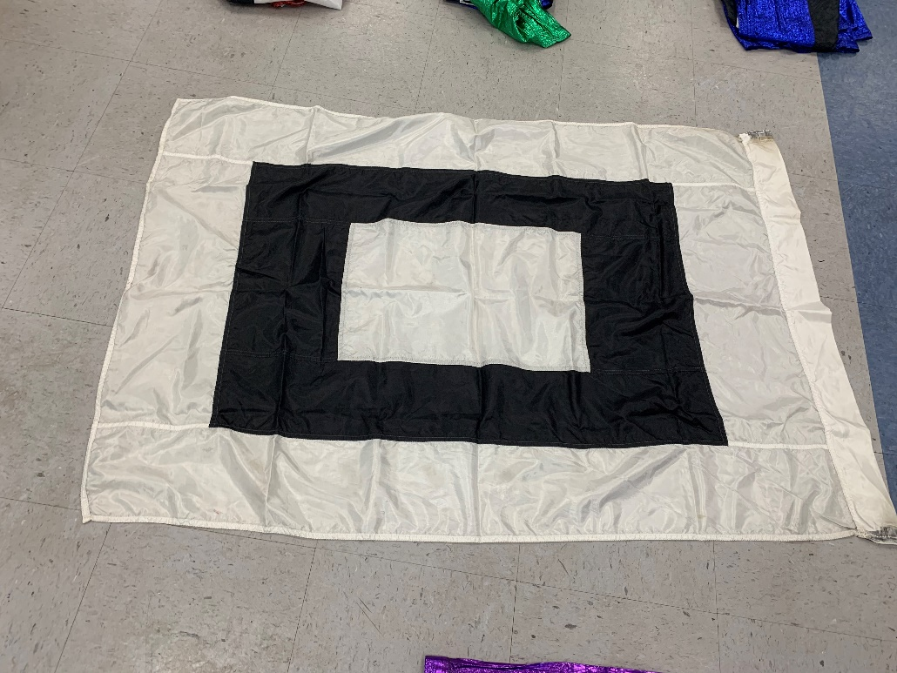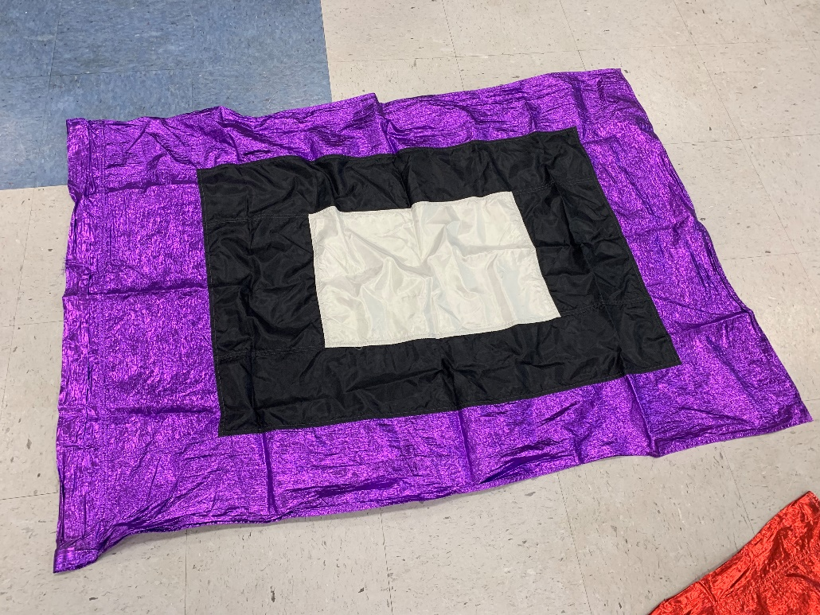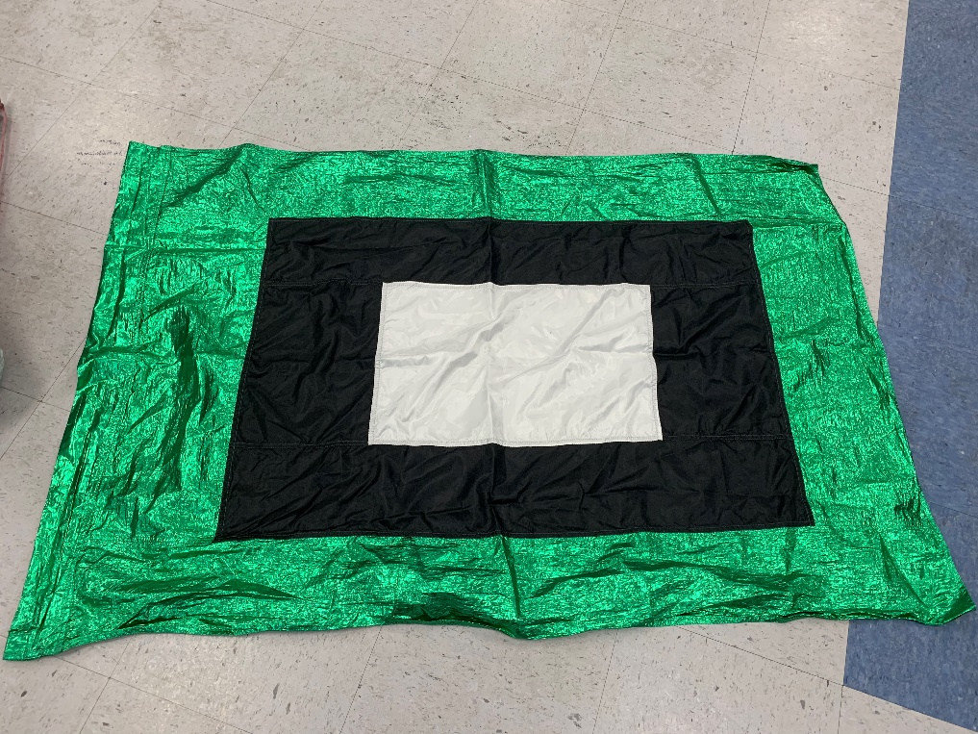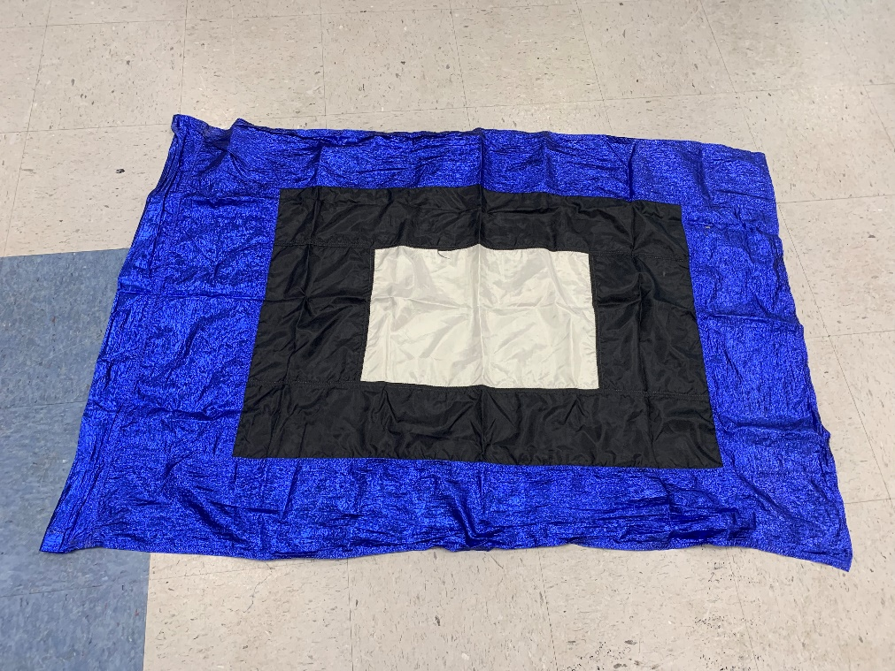
Rectangular patterned flags $5 each
Red (3 flags – 36”x51”)
Green (3 flags – 36”x51”)
Blue (4 flags – 36”x51”)
Royal Blue (3 flags – 35”x51”)
Purple (3 flags – 36”x51”)
White (3 flags – 35”x52”)

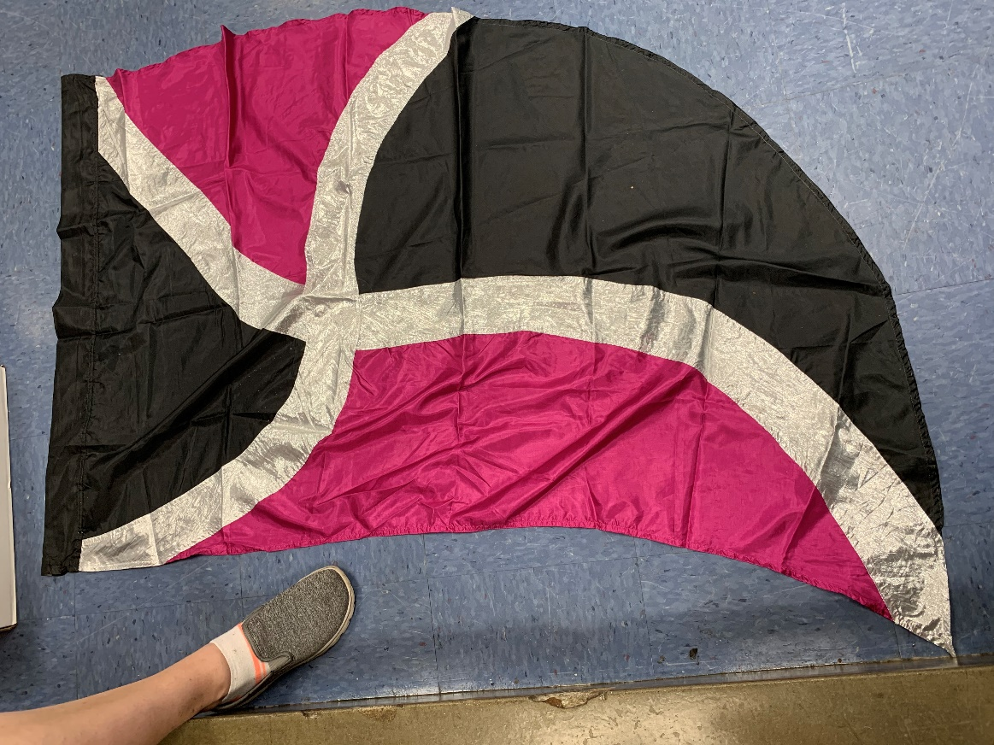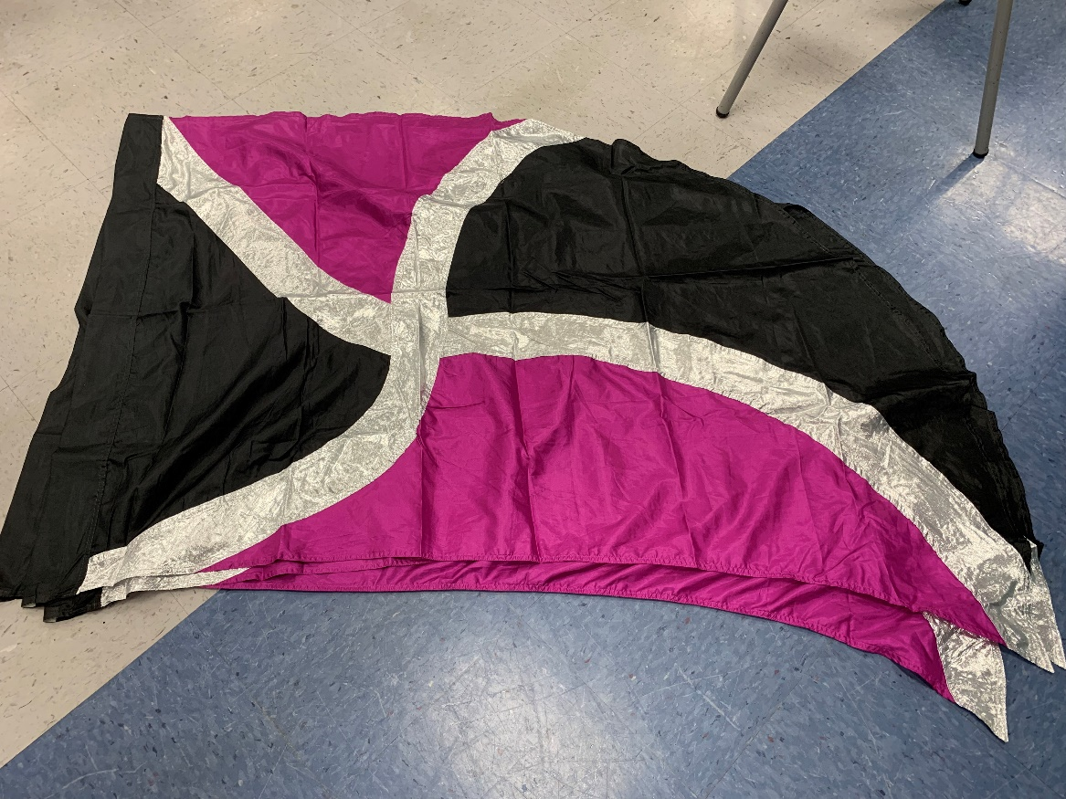Magenta/black with silver (11 flags – 35”x55”) $5 each
Purple/black with silver (3 flags – 35”x55”) $5 each

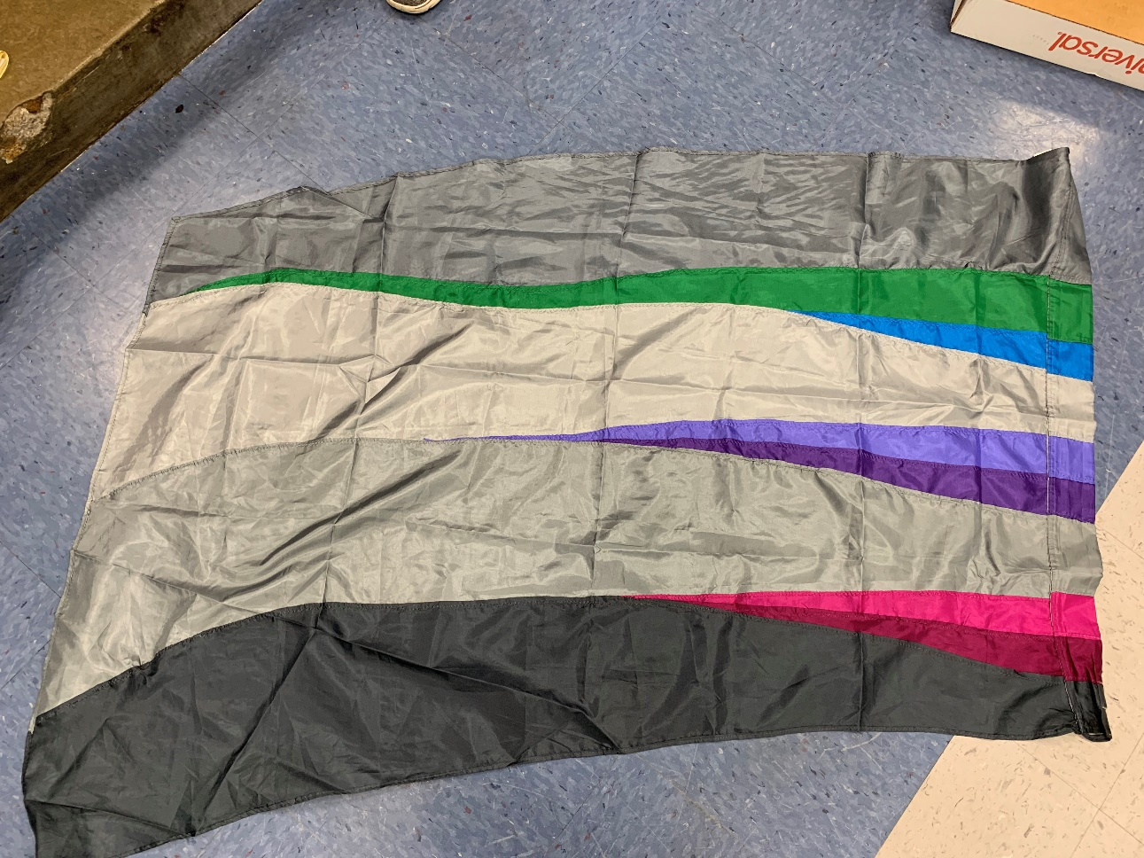
Gray with colored stripes (15 flags – 32”x52”) $5 each

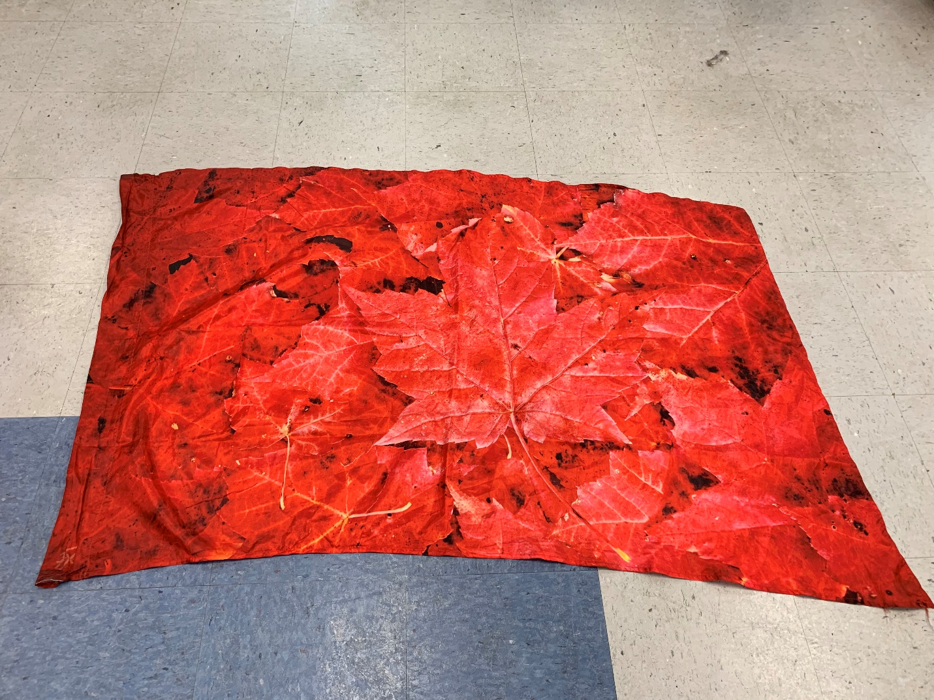
Red Maple leaves (10 flags – 36”x52”) $15 each

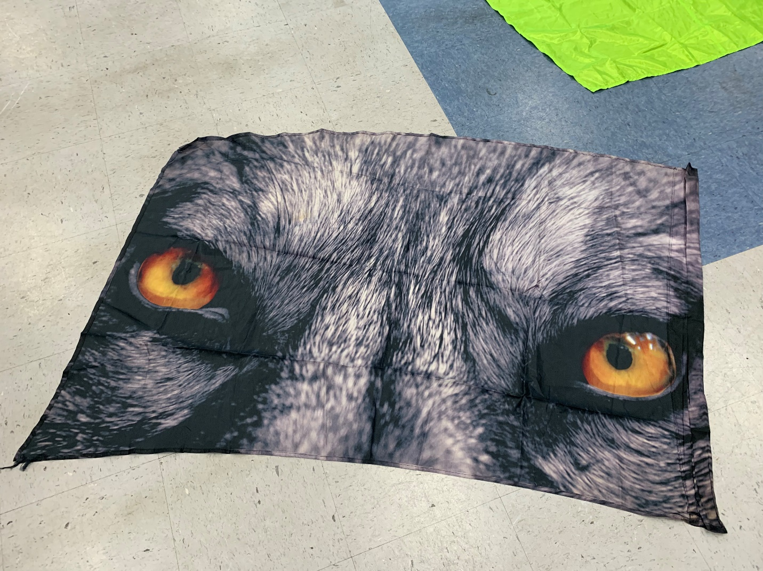Wolves (13 flags – 36”x52”) $15 each

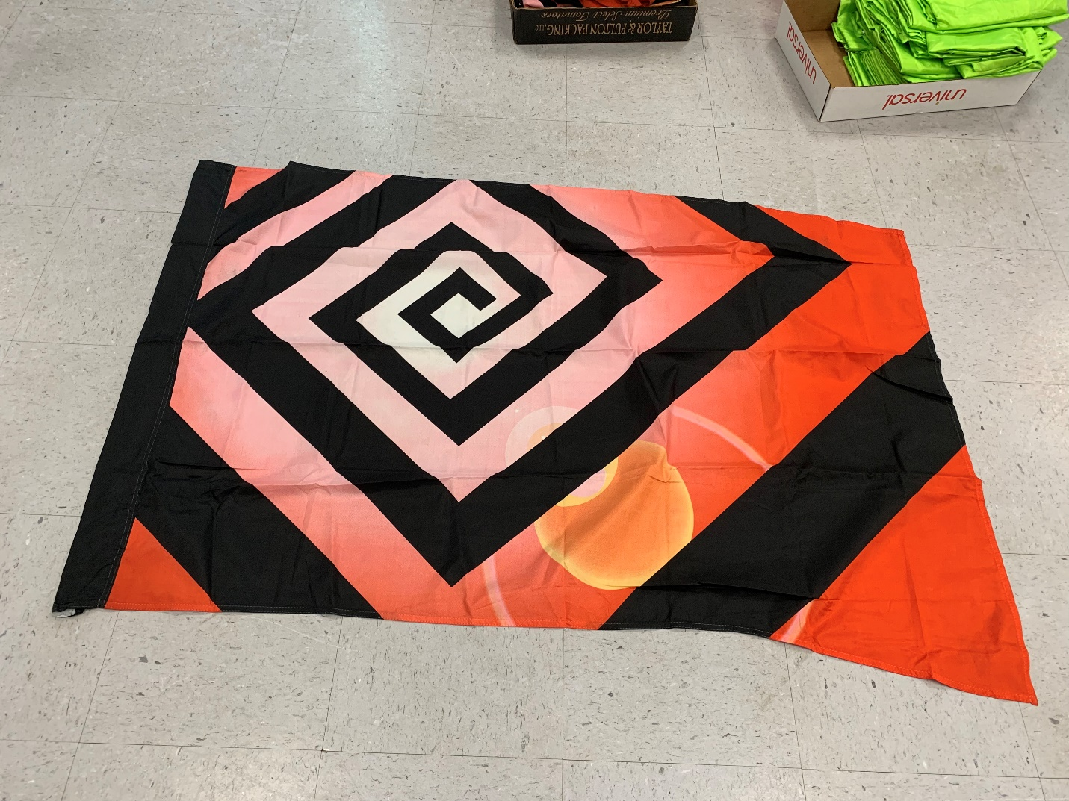
Black maze (27 flags – 35”x52”) $5 each

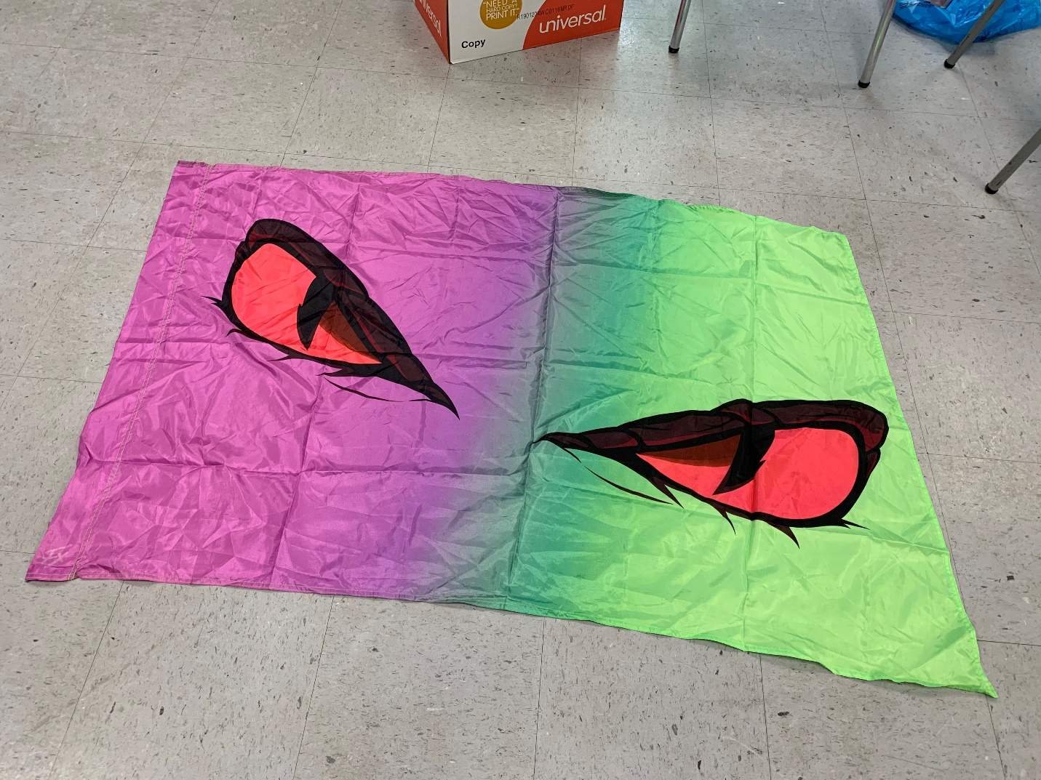
Snake eyes (15 flags – 36”x52”) $25 each

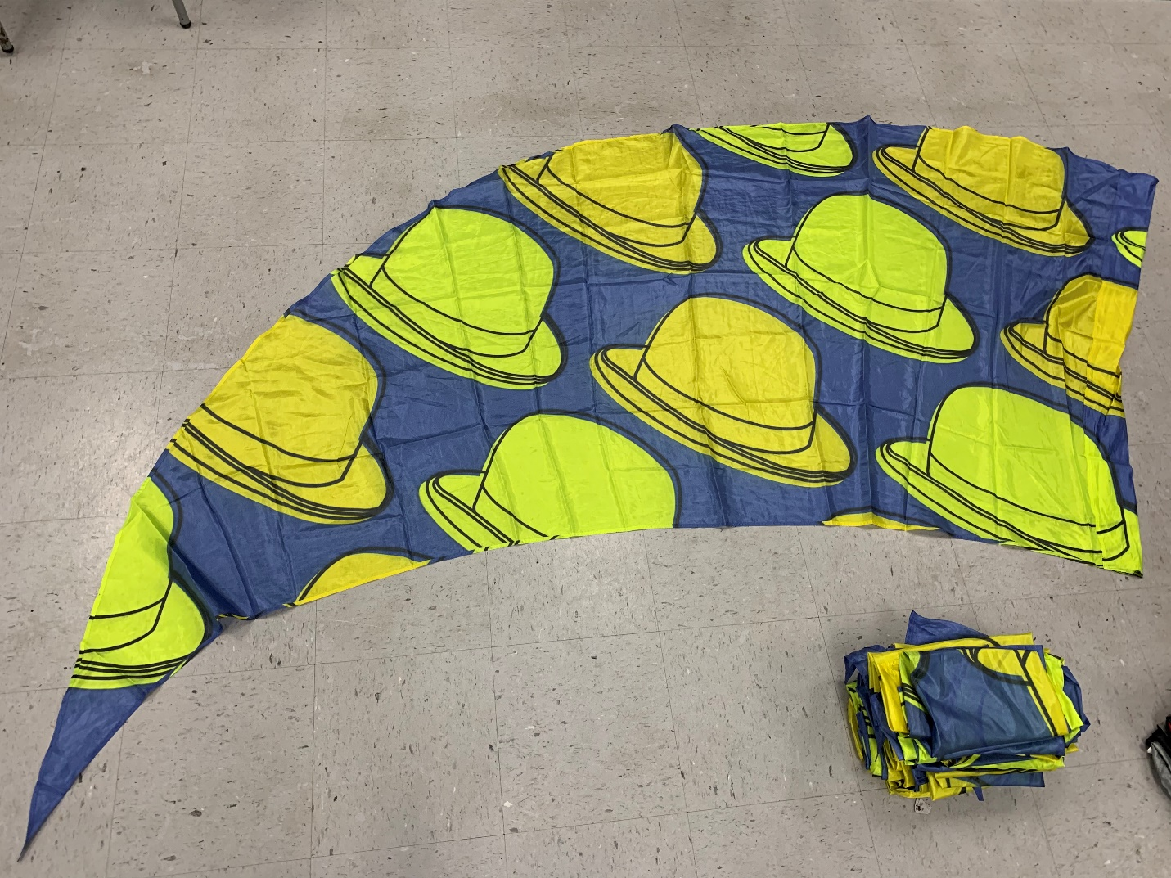
Bowler Hats (22 flags – 45”x115”) $30 each

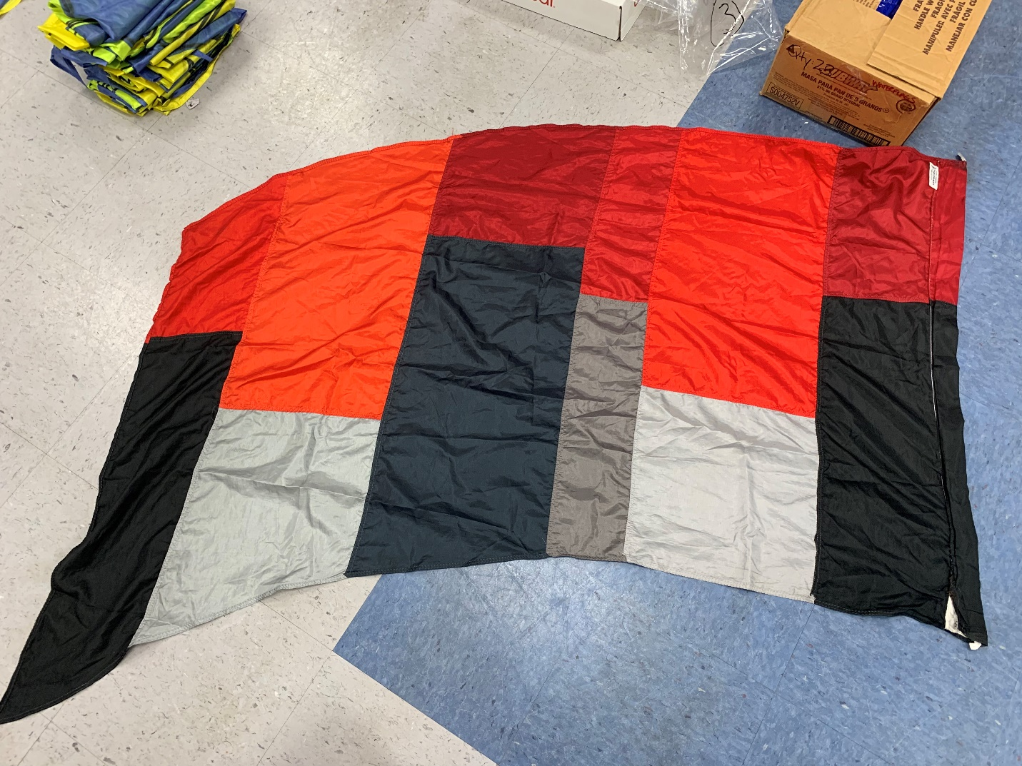
Multi color block (17 flags – 36”x78”) $15 each

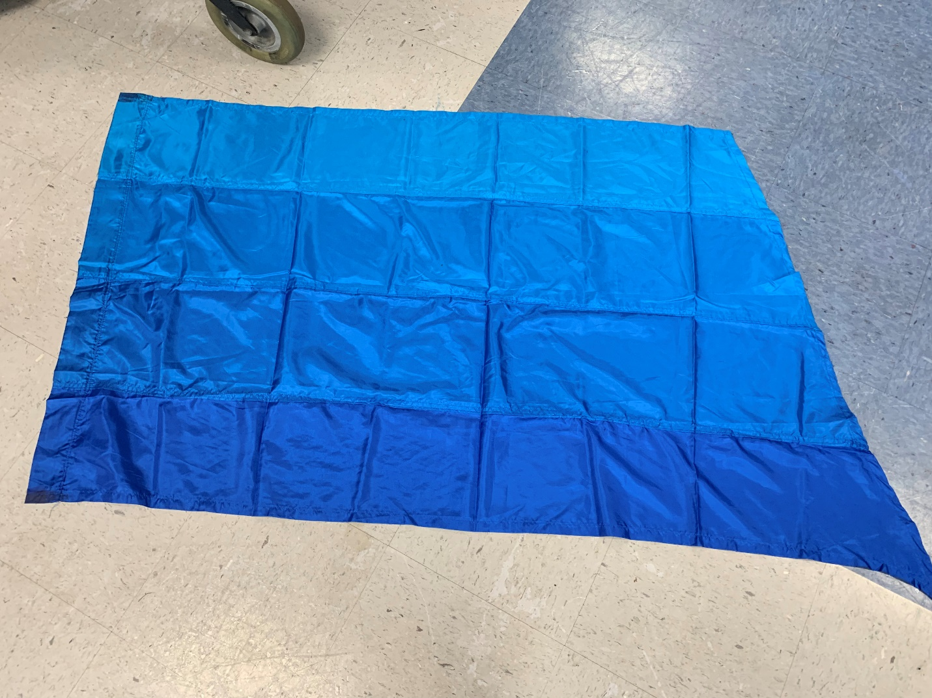
Multi blue (18 flags – 35”x68”) $10 each

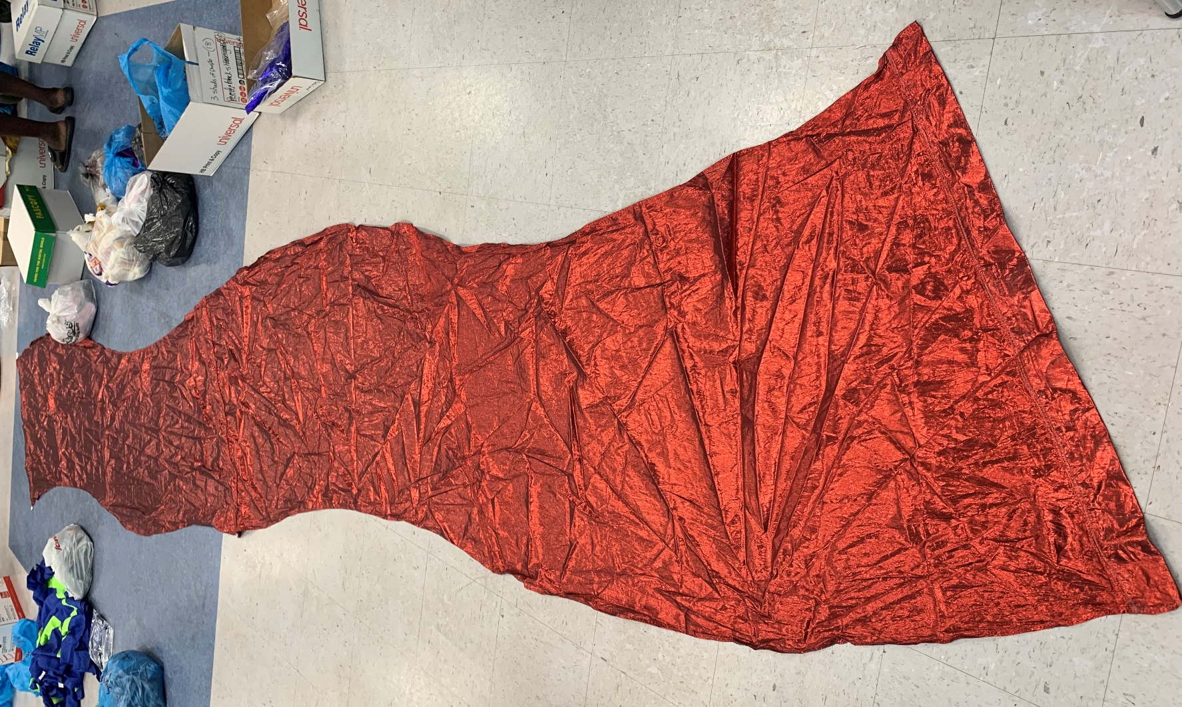
Red Shimmer – long (7 – 35”x18.5’)

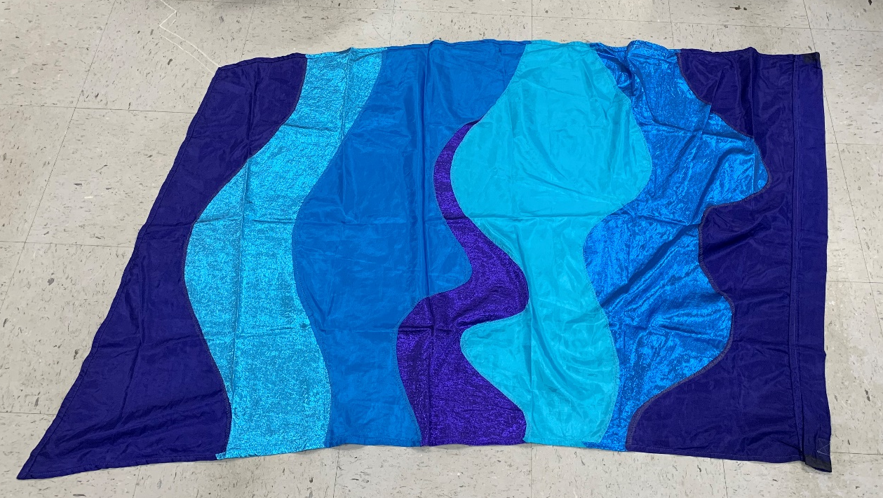
Multi blue wave (22 flags – 35”x52”) $10 each

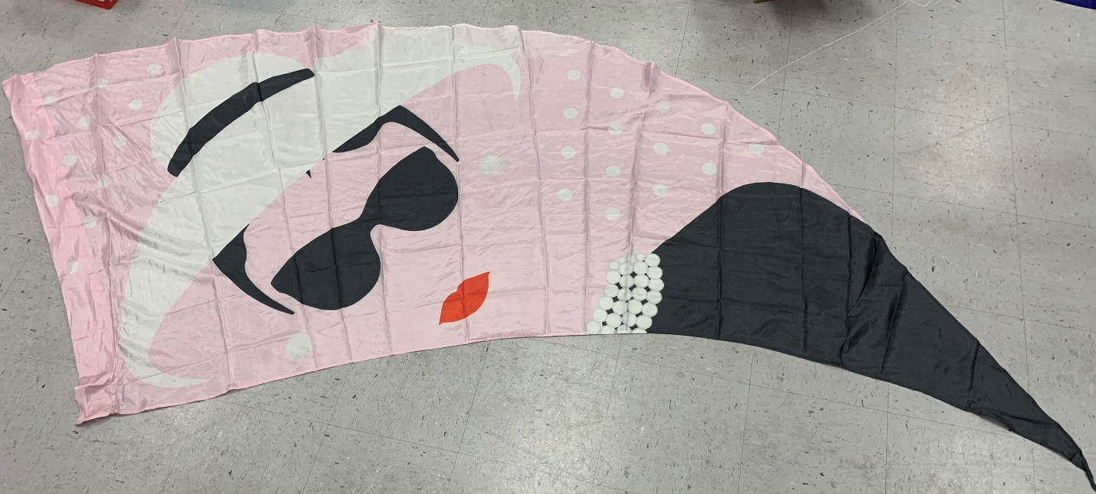
Pink Audrey Hepburn (30 flags – 45”x115”) $30 each

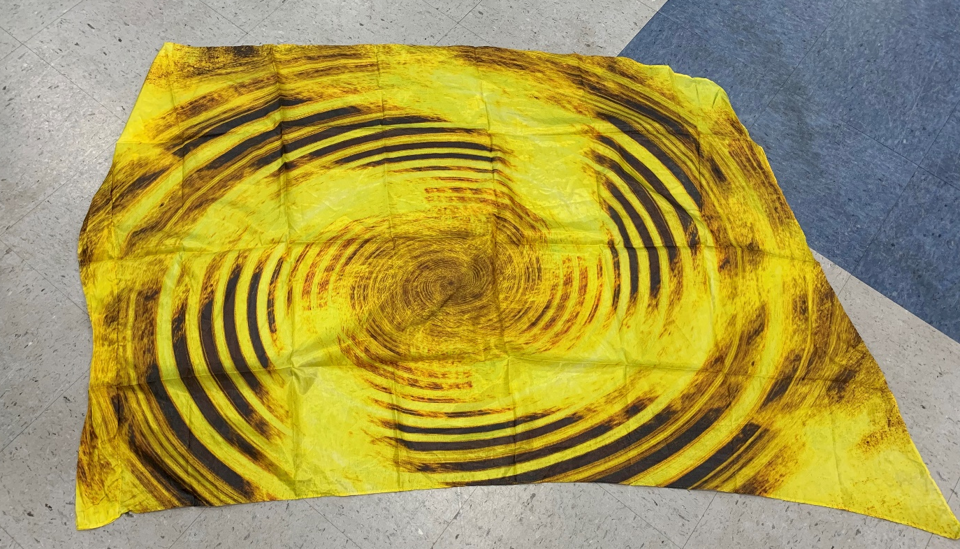Yellow swirl (32 flags – 36”x52”) $25 each

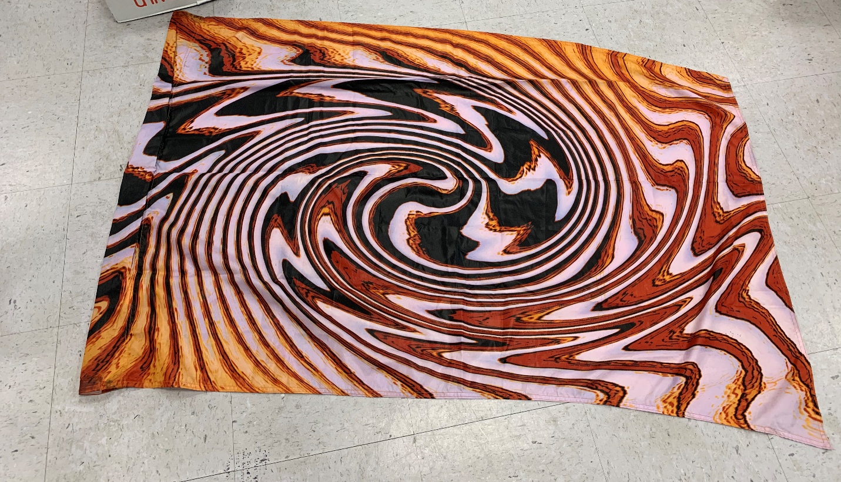
Kaleidiscope “bacon” (21 flags – 36”x52”) $10 each

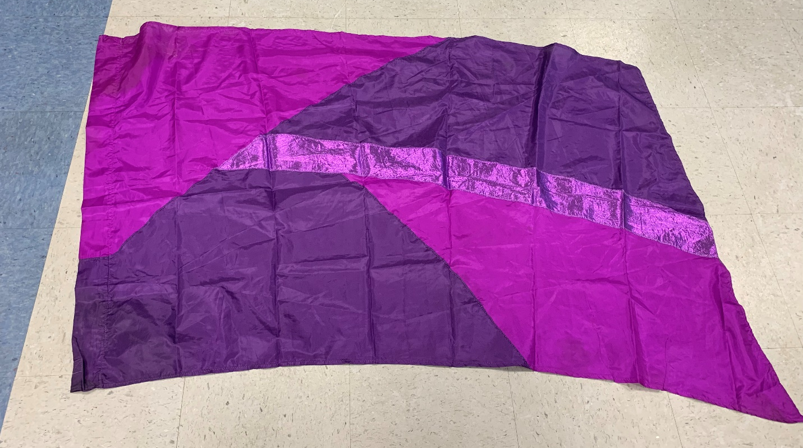
Purple multi-color (14 flags – 35”x71”) $10 each

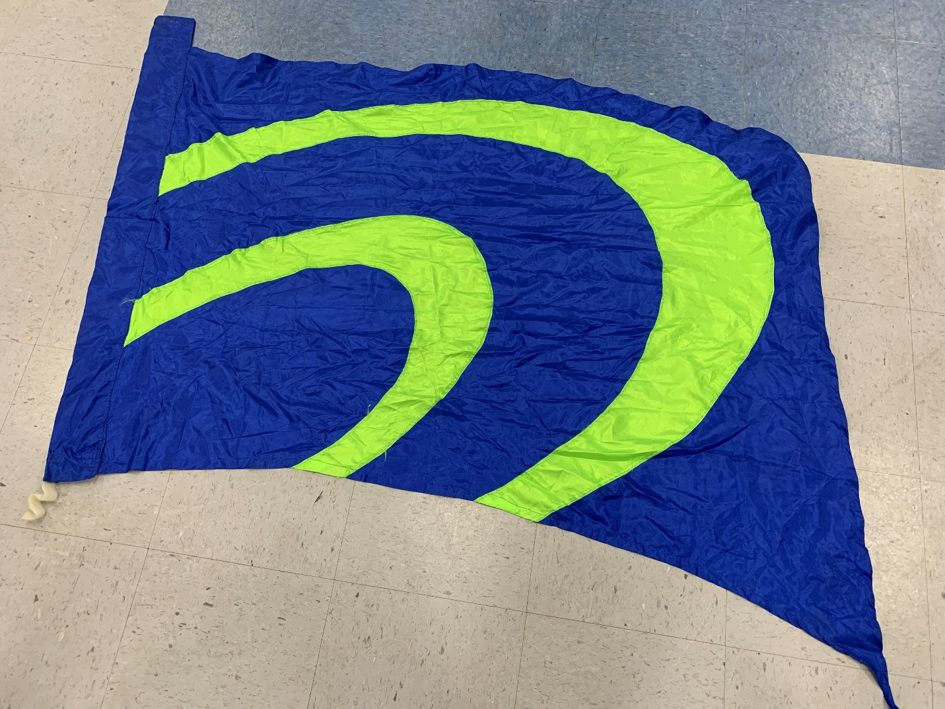
Blue with lime green (12 flags – 39”x75”) $5 each

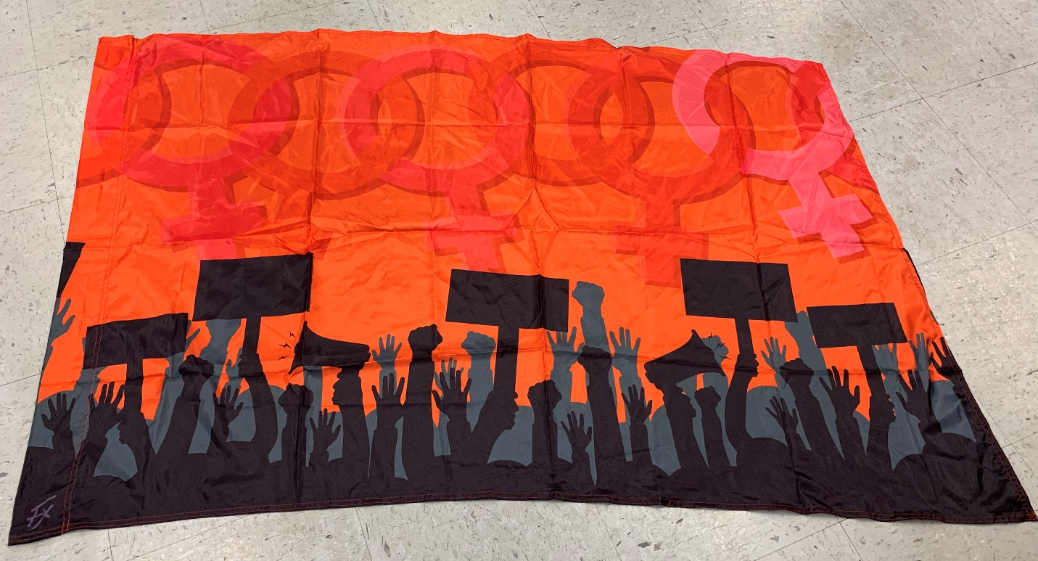
Women protest flag (14 flags – 36”x52”) $25 each

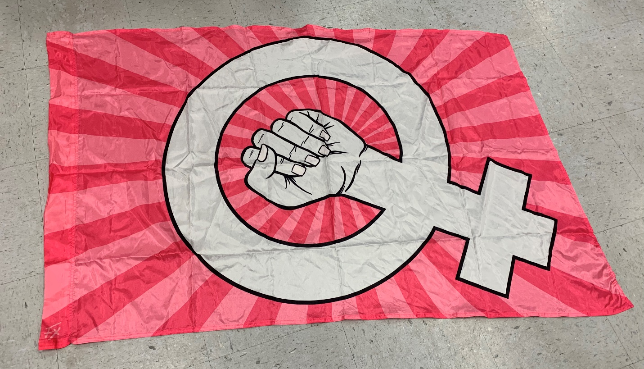
Pink women protest flag (14 flags – 36”x52”) $25 each

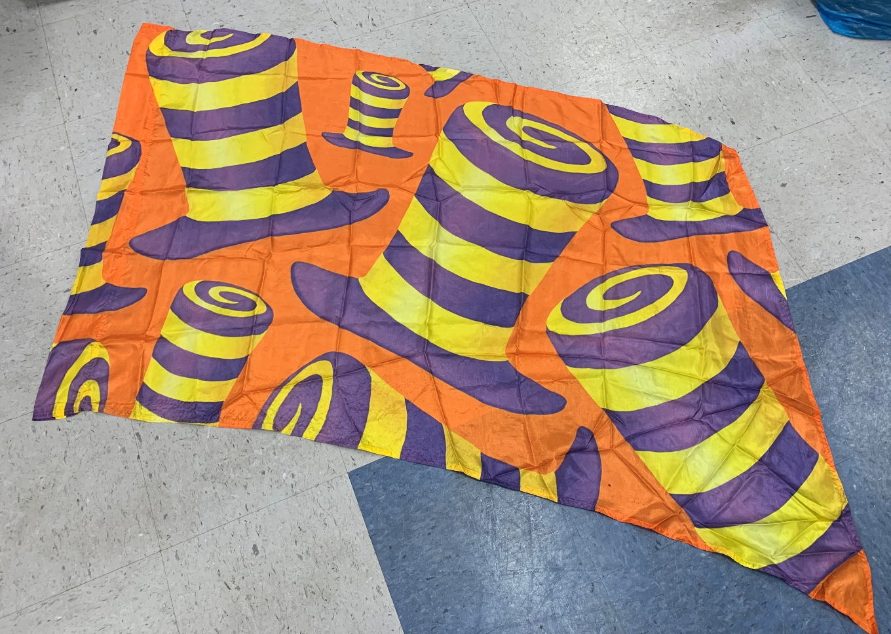
Mad Hat flags (32 flags – 36”x55”) $30 each

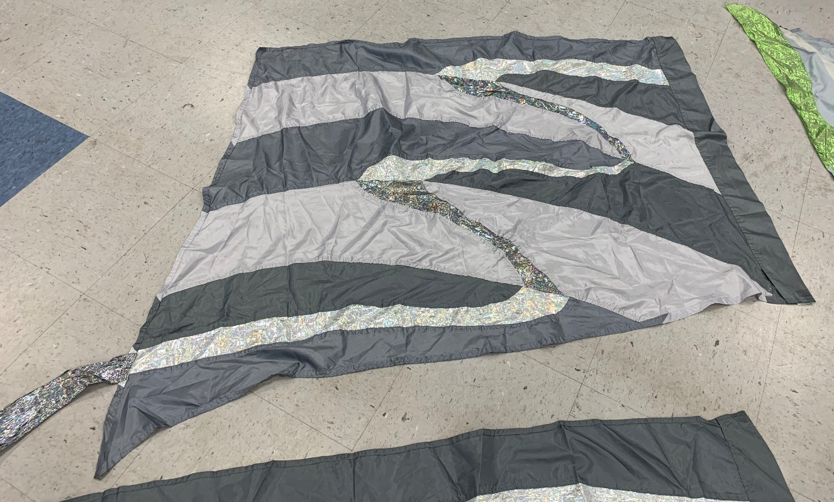
Multi-Gray (19 flags – 35”x69”) $5 each

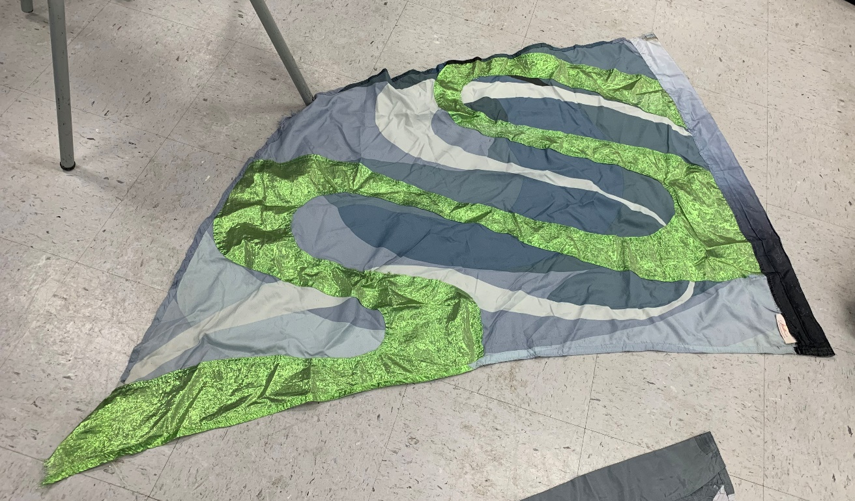
Gray and green swing flag (16 flags – 35”x54”) $5 each

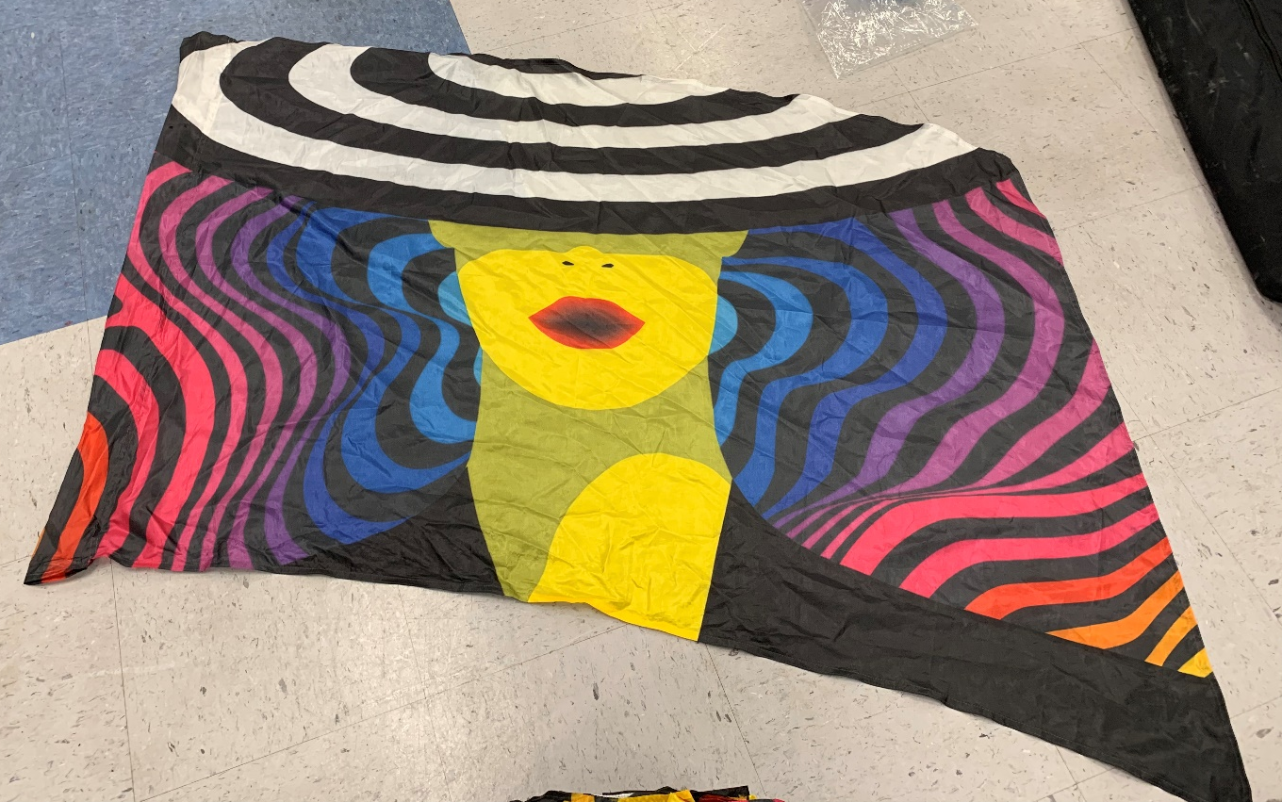Lady Gaga rainbow (32 flags – 36”x55”) $25 each

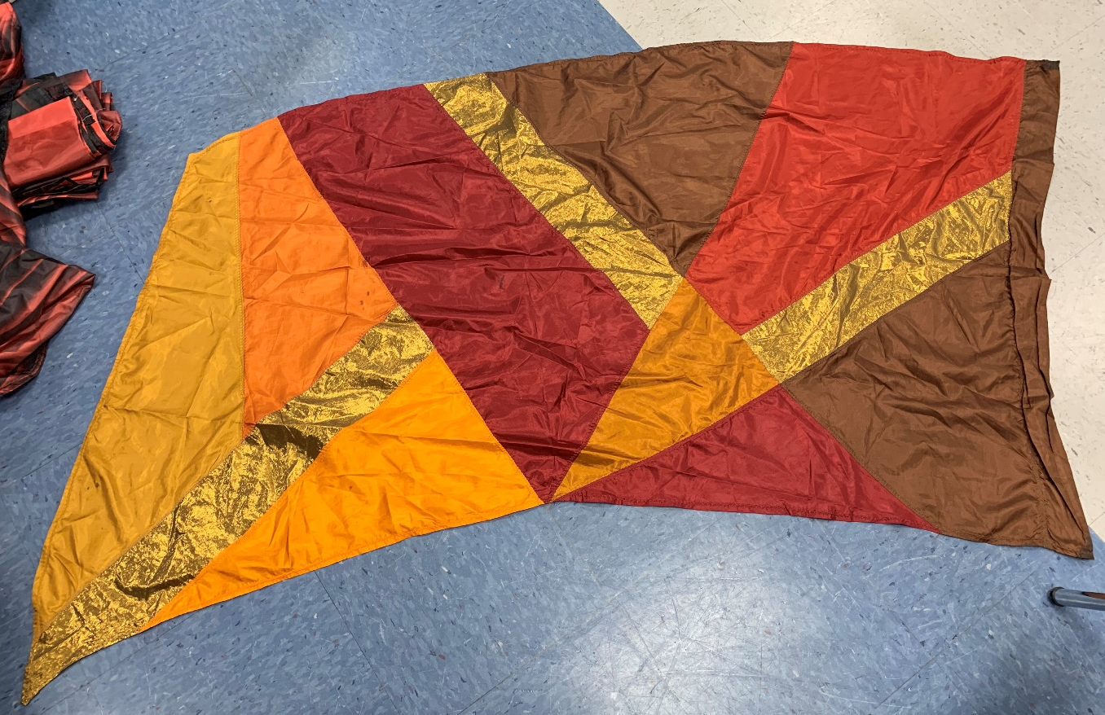
Fall multi color (18 flags – 34”x55”) $15 each
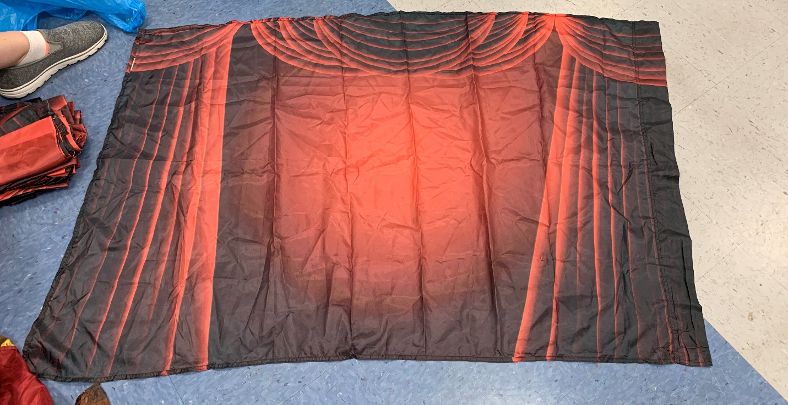
Red theater curtain (12 flags – 35”x52”) $30 each

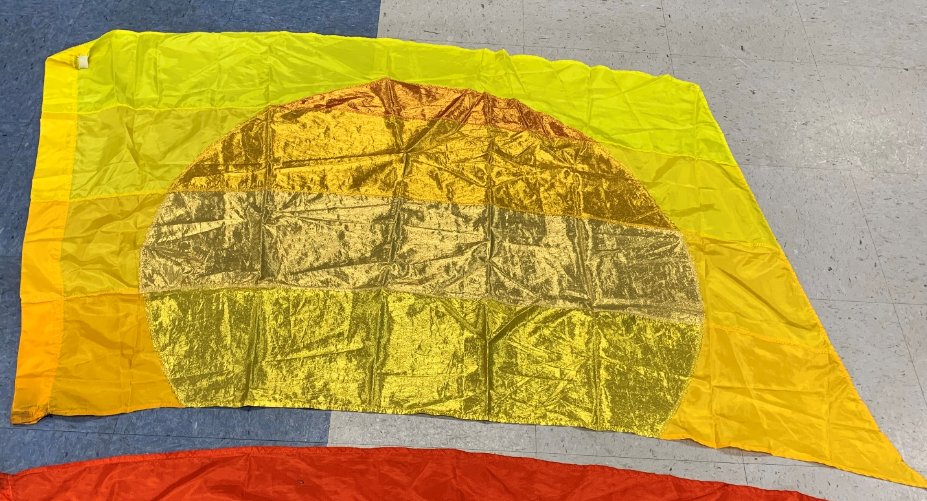
Sunrise (16 flags, 34”x69”) $20 each

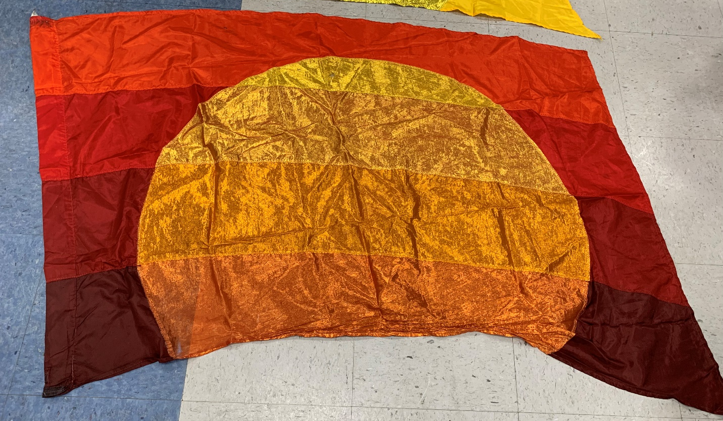
Sunset (16 flags, 34”x69”) $20 each

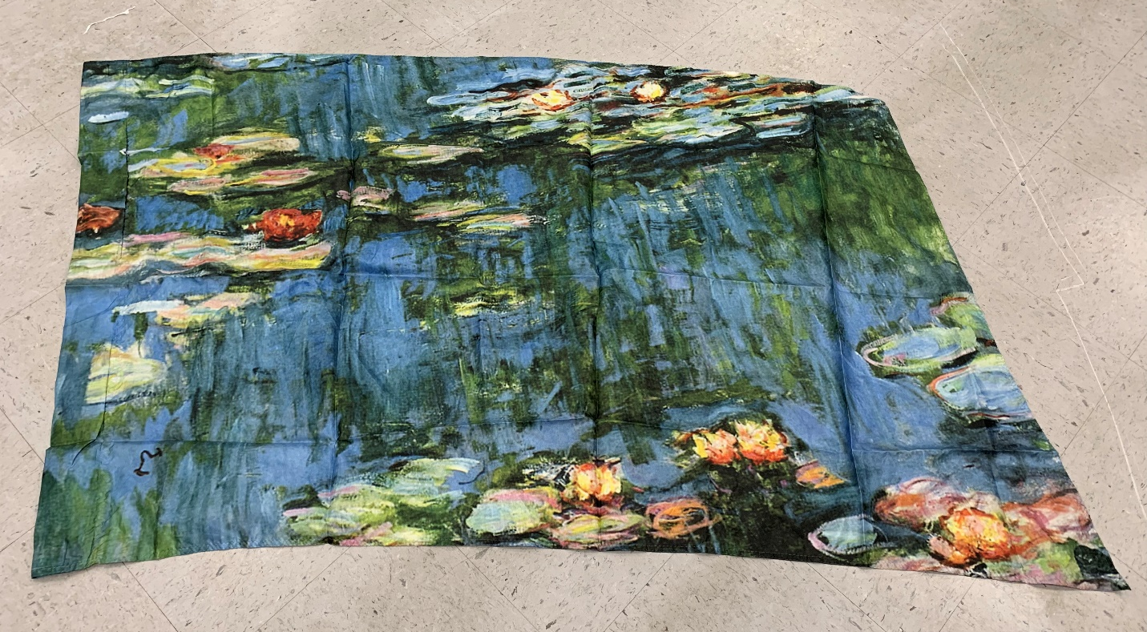Monet, Water Lily (____ flags, 36”x52”) $30 each

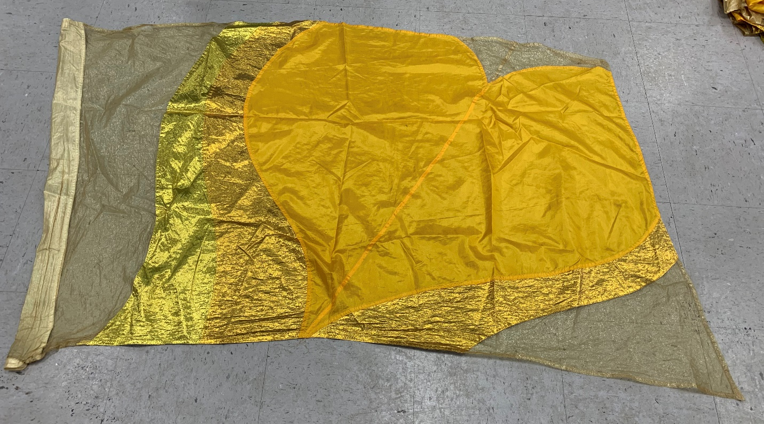
Yellow Heart (5 flags – 37”x59”)

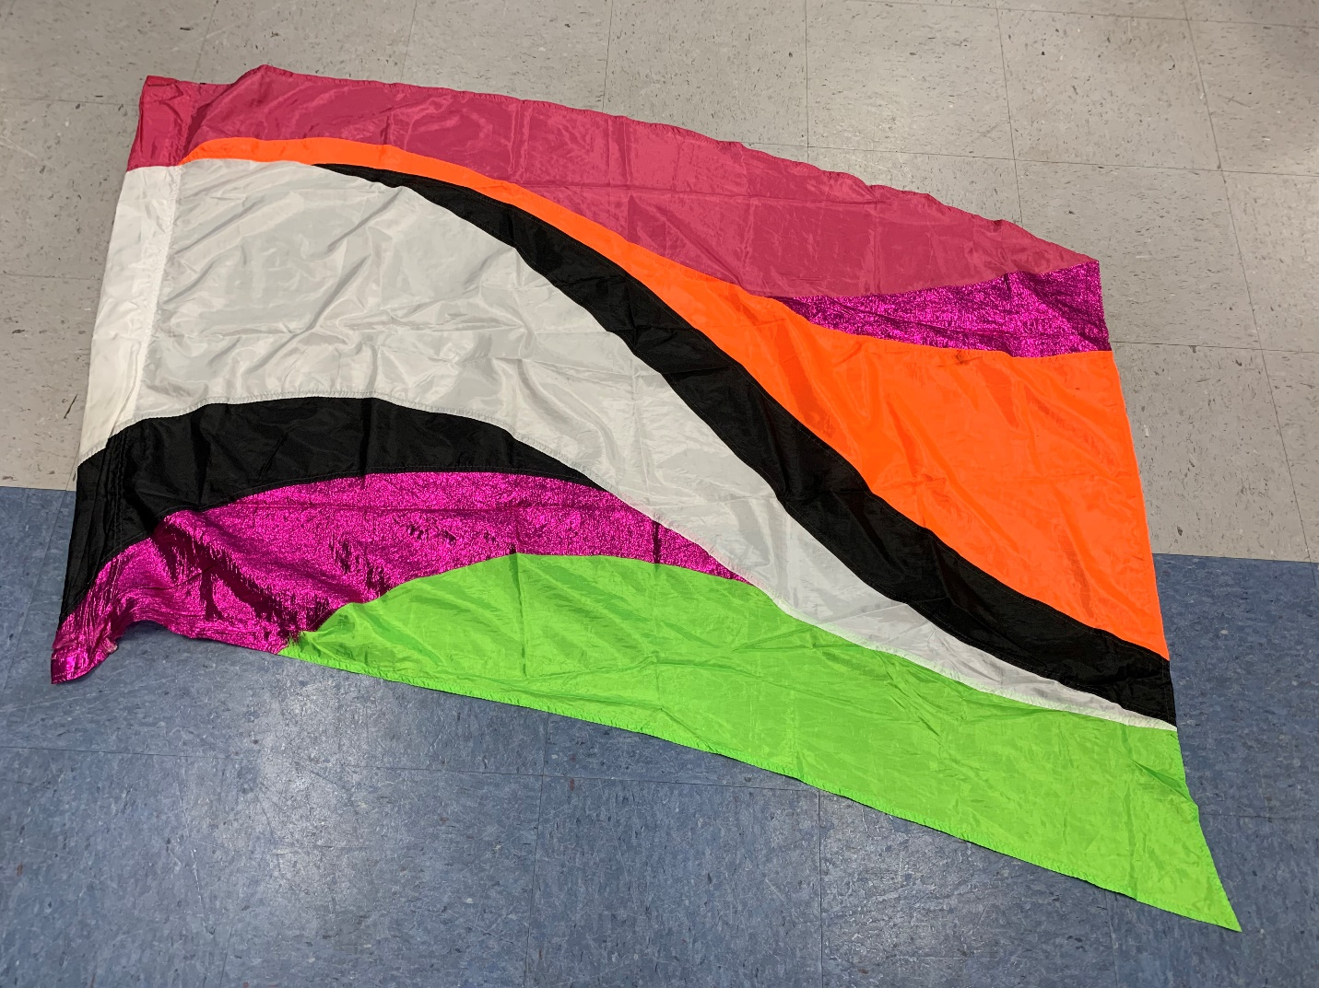
Magenta multi color (10 flags – 36”x54”) $10 each

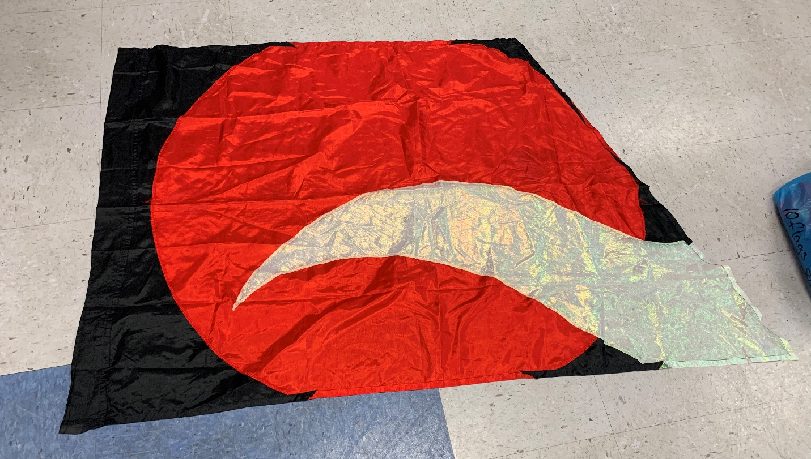Red circle with black (10 flags – 35”x65”) $10 each

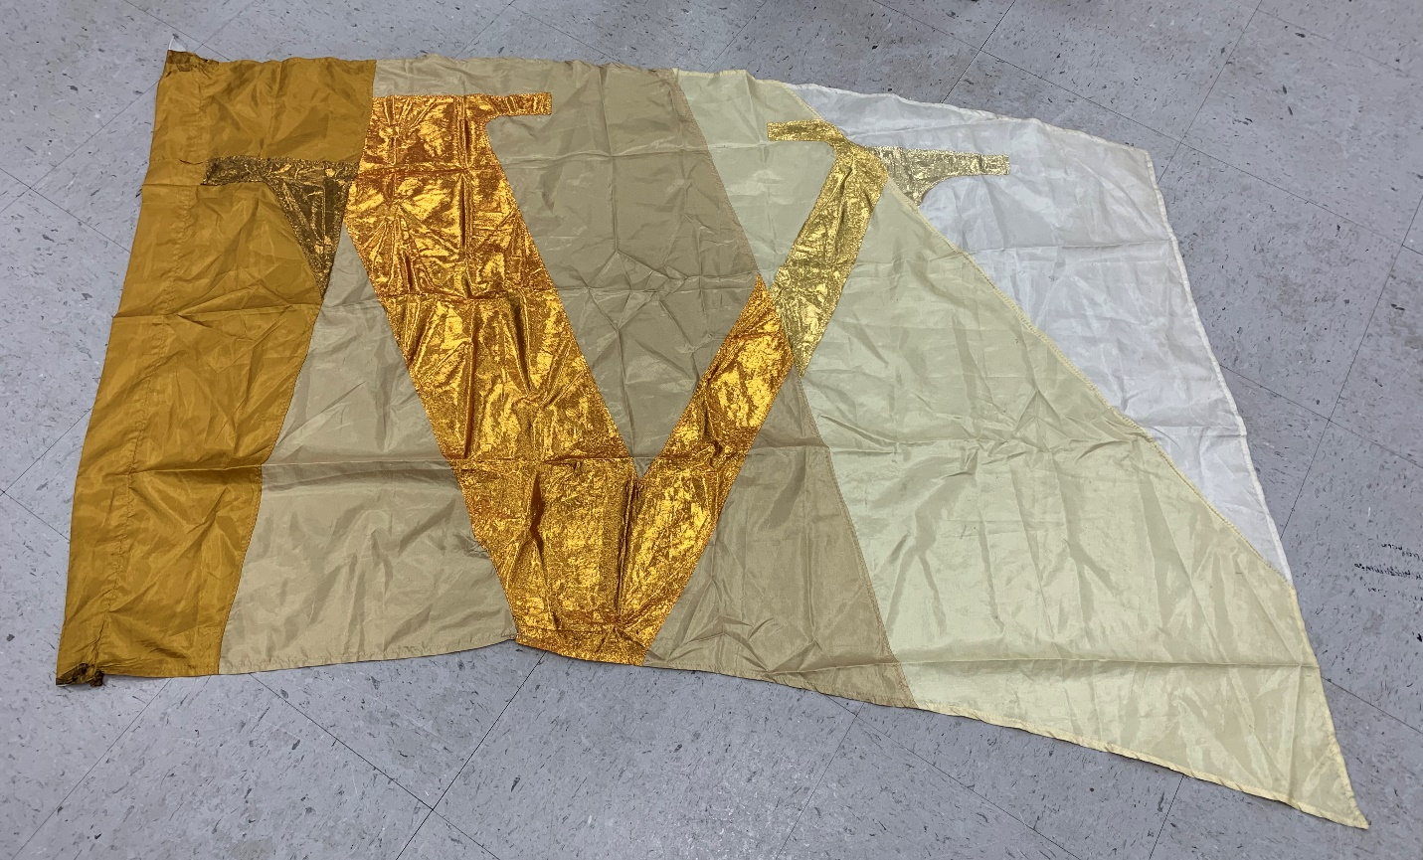
Gold V (11 flags – 35”x53”) $15 each

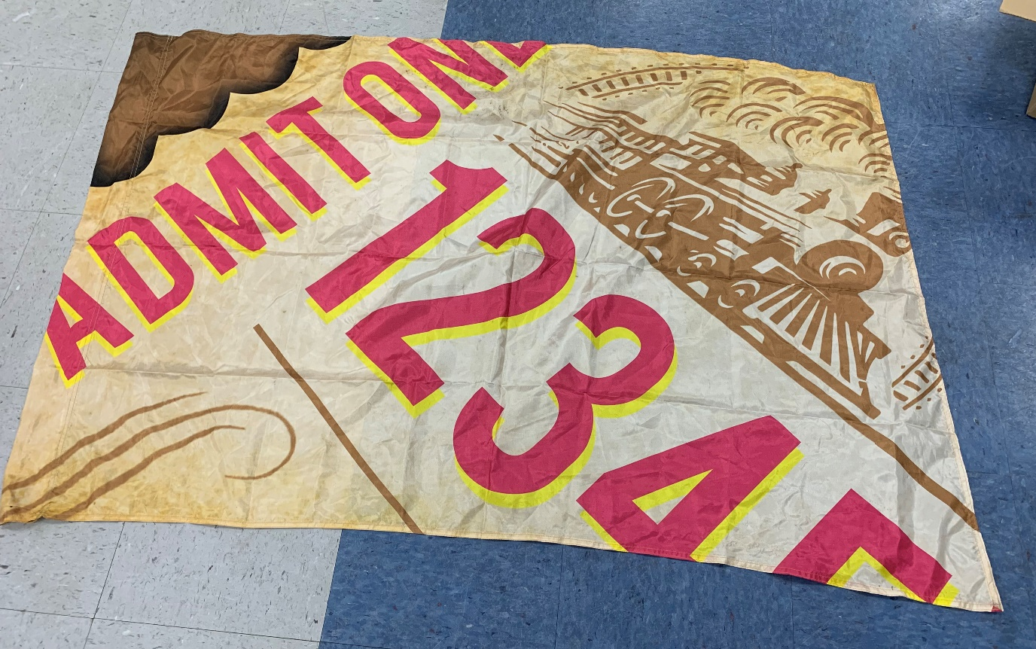Train ticket (11 flags – 36”x52”) $30 each

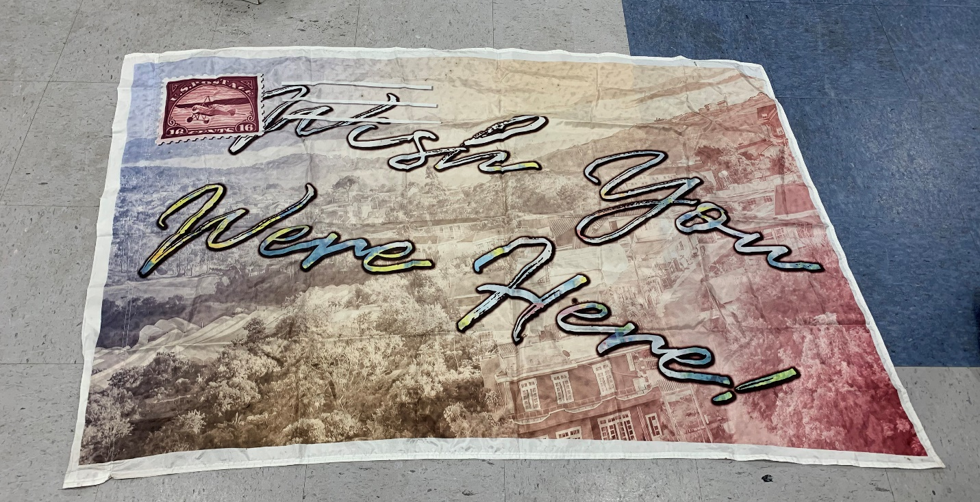
Postcard (24 flags – 36”x52”) $30 each
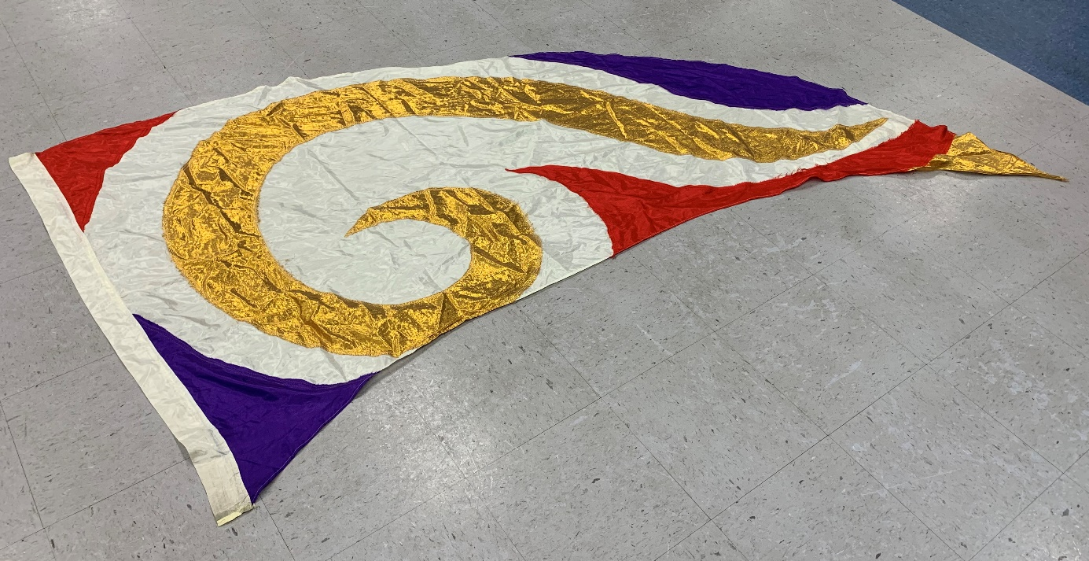
Gold swirl swing flag (21 flags – 46”x103”) $10 each

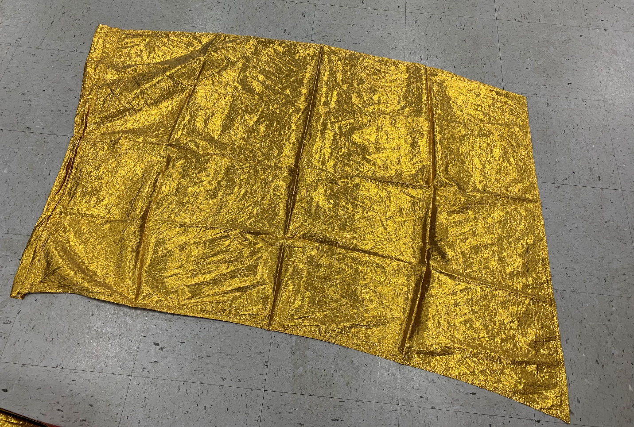
Gold shimmer (23 flags– 36”x54”) $10 each
Gold shimmer (40 flags with torn pole seam – 36”x54”) $5 each
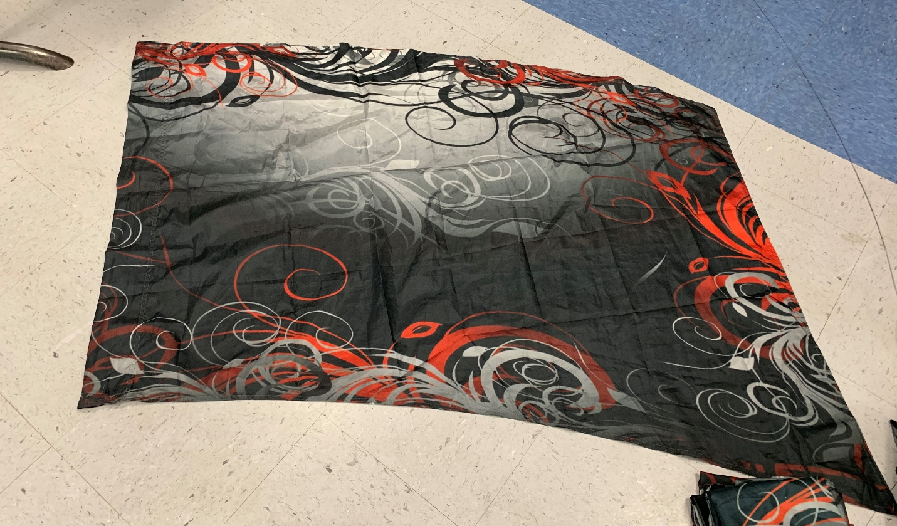
Black/red swirl – fair condition (12 flags – 35”x53”) $10 each

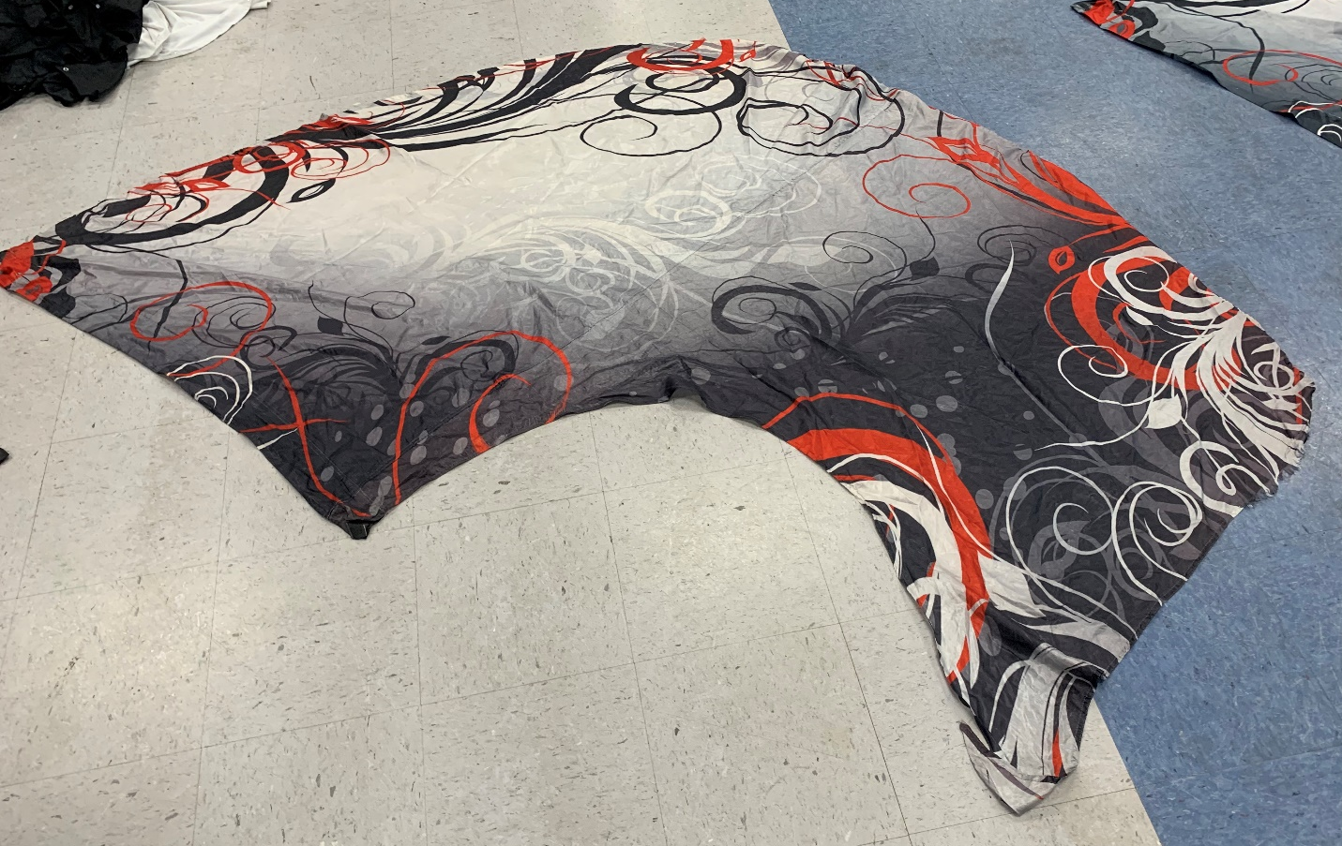
Oversized swing flag, black/red swirl – fair condition (20 flags – 44”x100”) $15 each
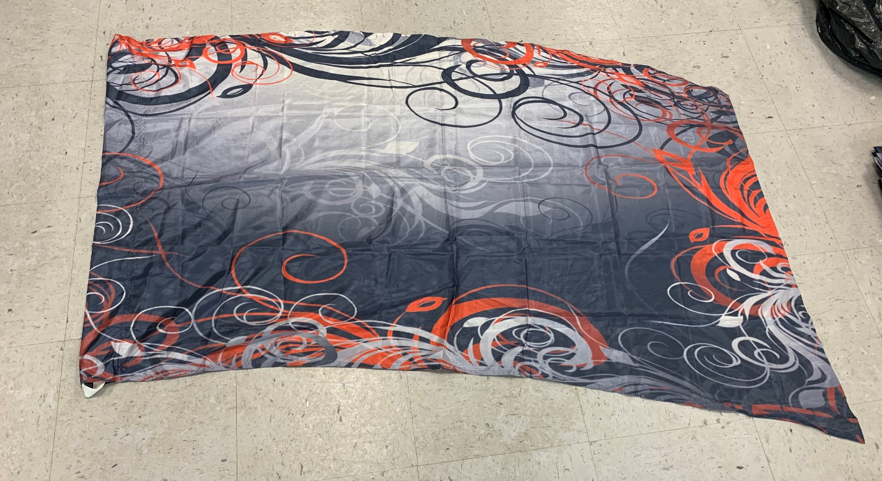
Never used black/red swirl (16 flags – 33”x54”)

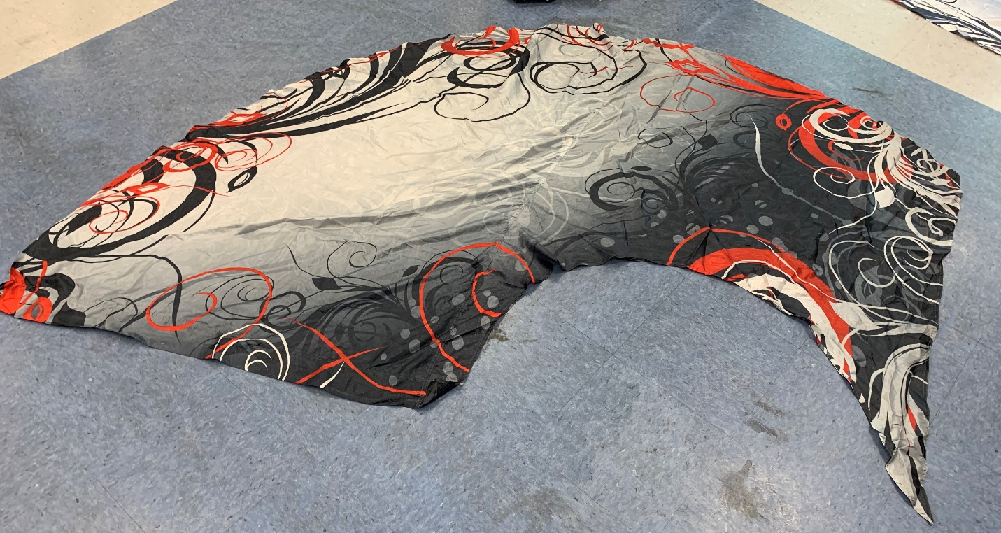
Never used oversized swing flag, black/red swirl (7 flags – 44”x100”)

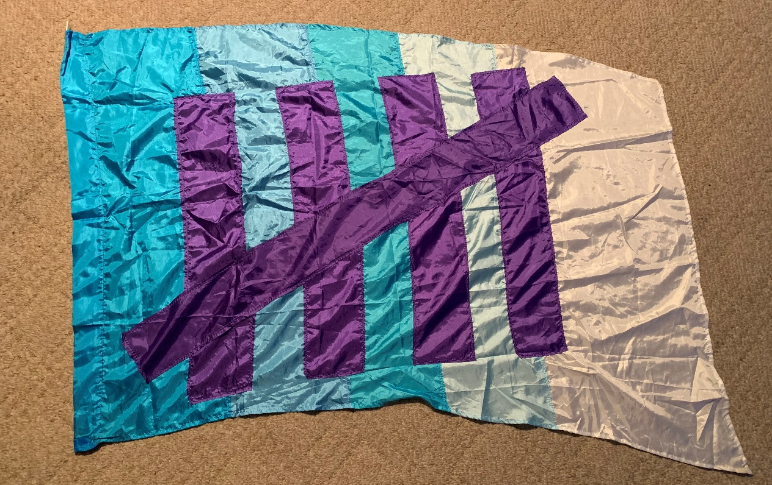

5 flag (12 flags – 36”x54”)

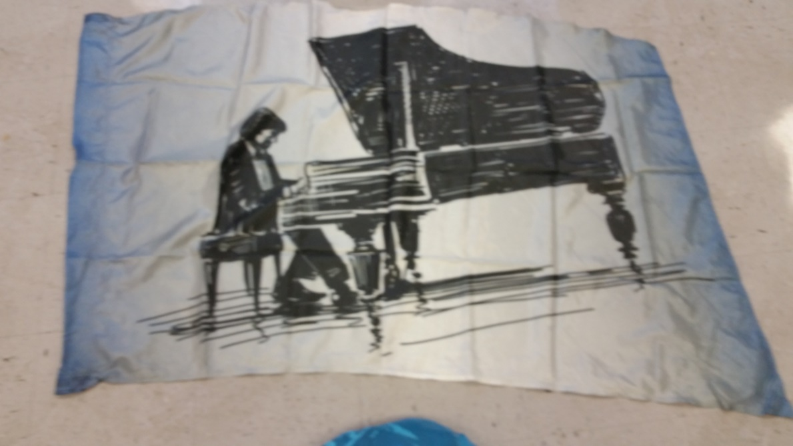

Piano Flags (12 flags – 36”x52”) $25 each
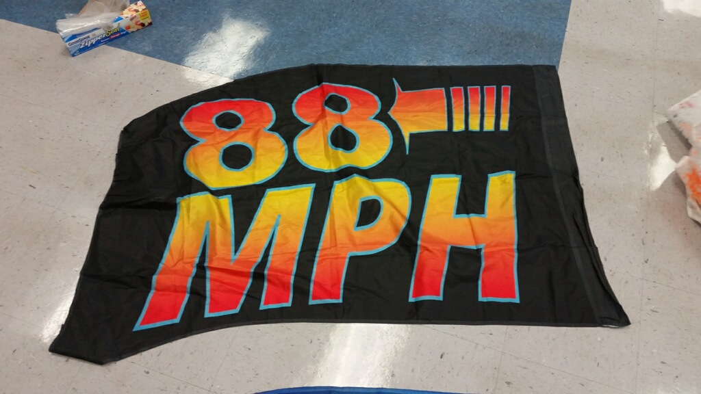

Back to the Future – 88 mph (20 flags {15 excellent, 5 fair} – 36”x52”) $15 each

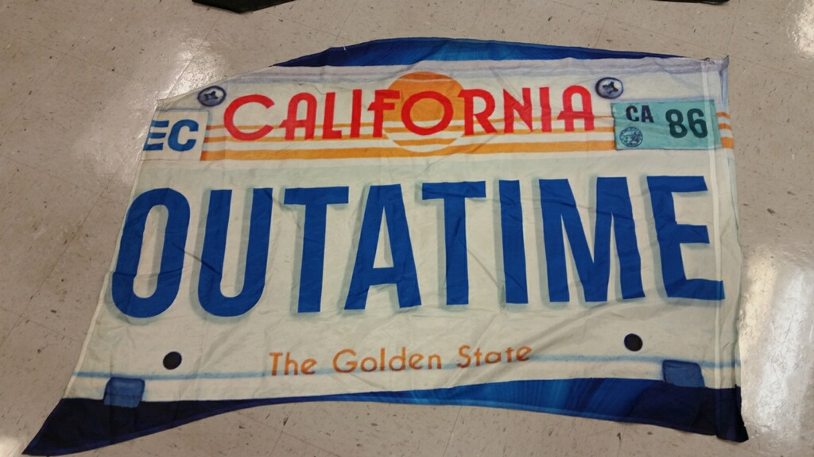

Back to the Future – license plate (19 flags {13 excellent, 6 fair} – 36”x52”) $15 each
20 white/black transformation costumes with bling $25 each
(5 small, 6 medium, 6 large, 2 XXL, 1 XXXL)
9 white/black transformation costumes, no bling $20 each
(2 XS, 2 small, 1 medium, 2 large, 1 XL, 1 XXXL)
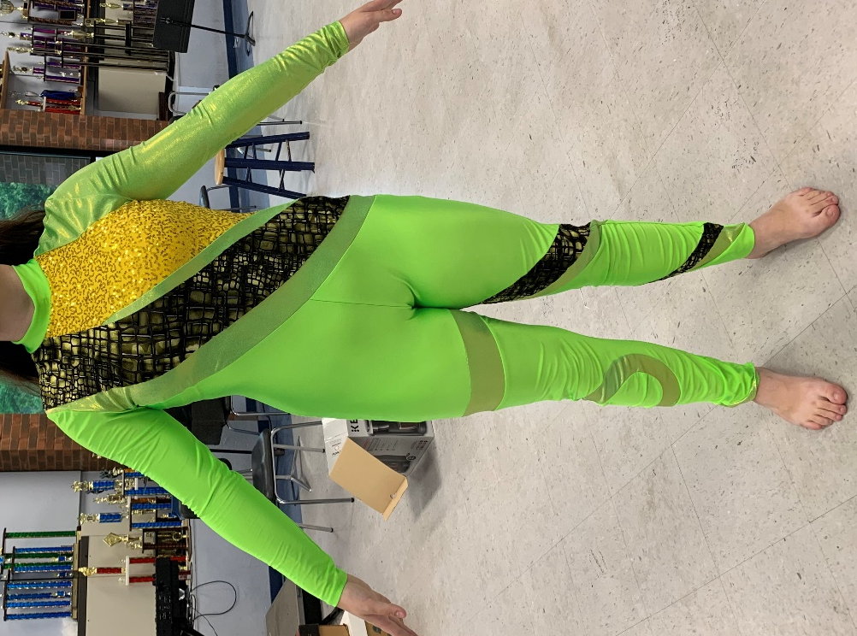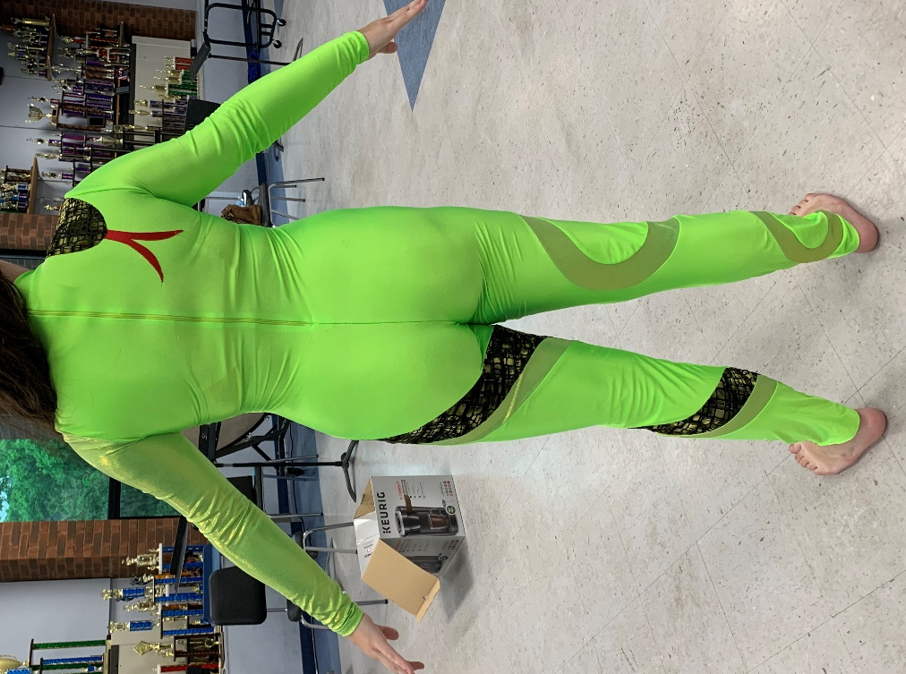
44 – Charmed costumes - $85 each
(12 small, 11 medium, 15 large, 5 XL, 1 male medium)

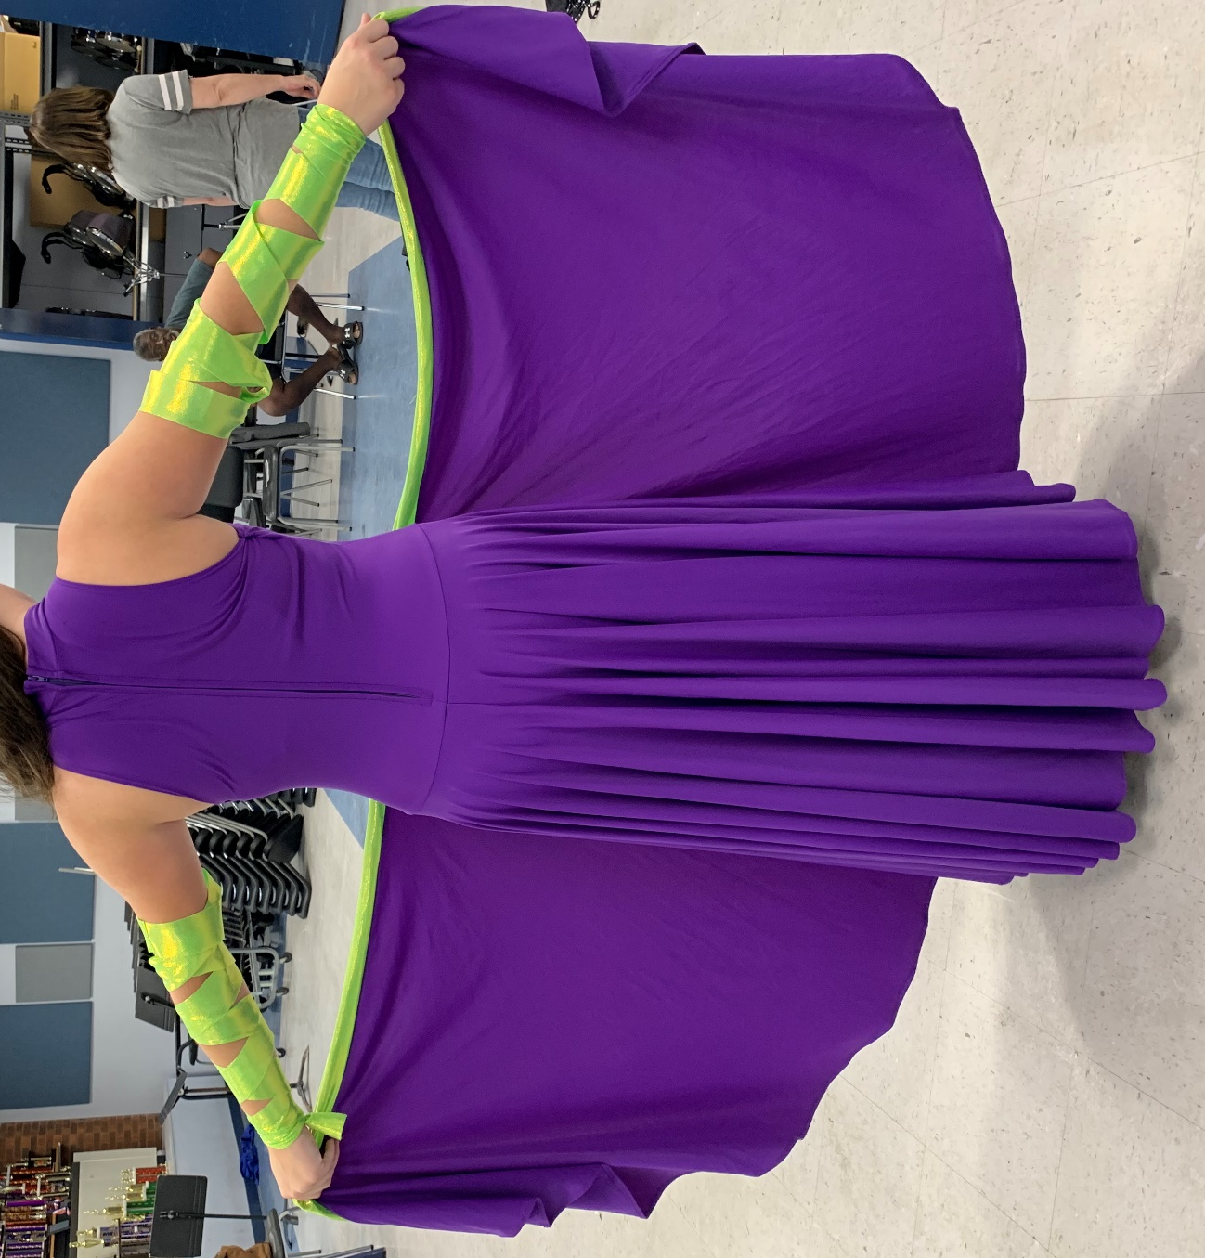
8 large (1 is unopened) with armbands – Witch costumes - $75 each

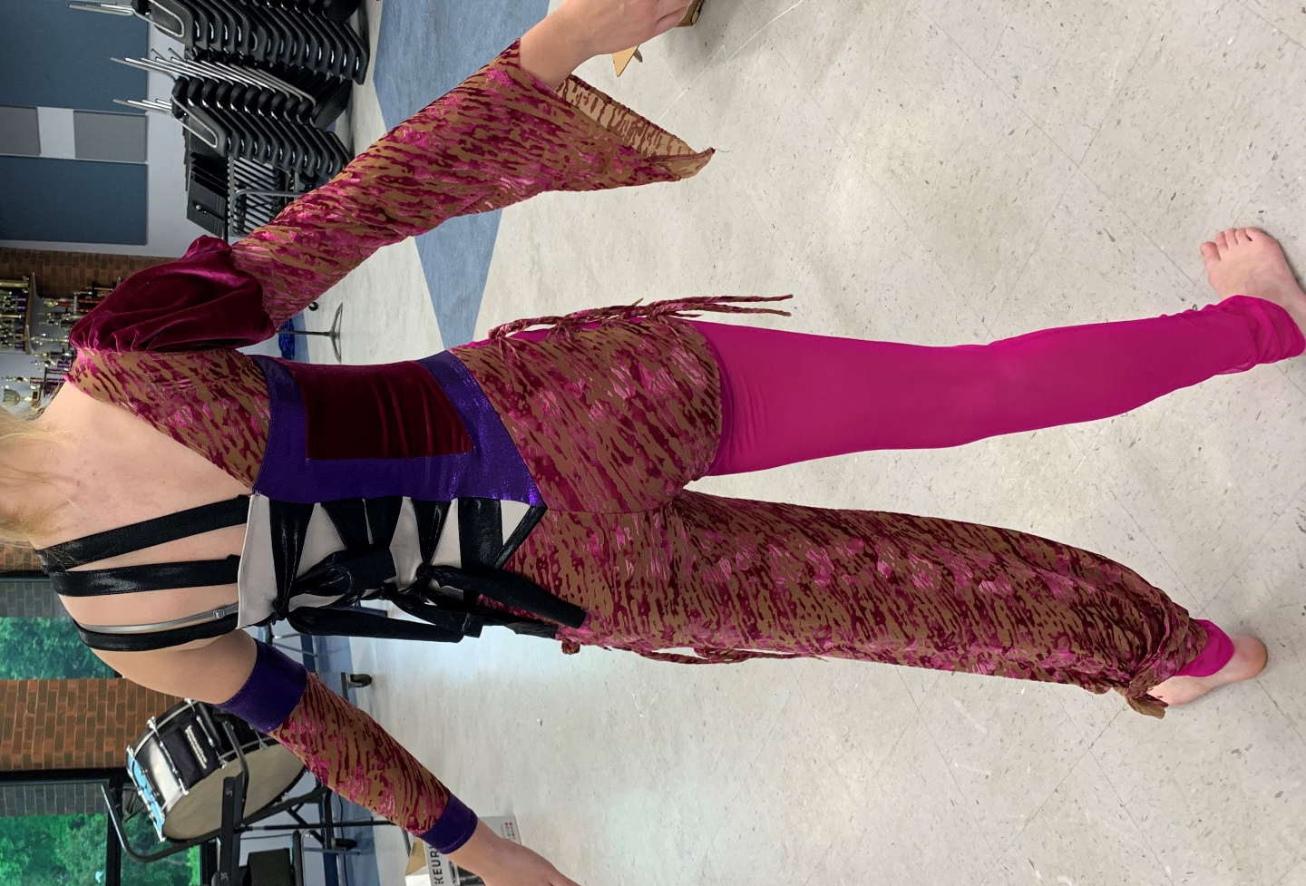
Mad Hat costumes

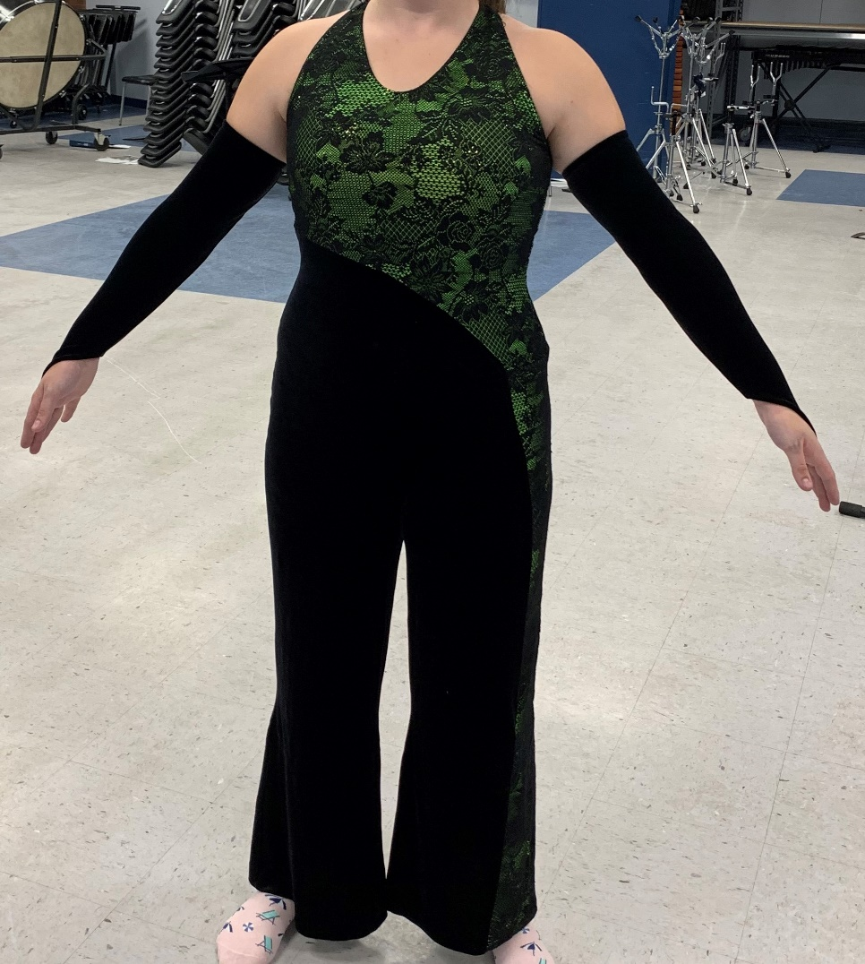
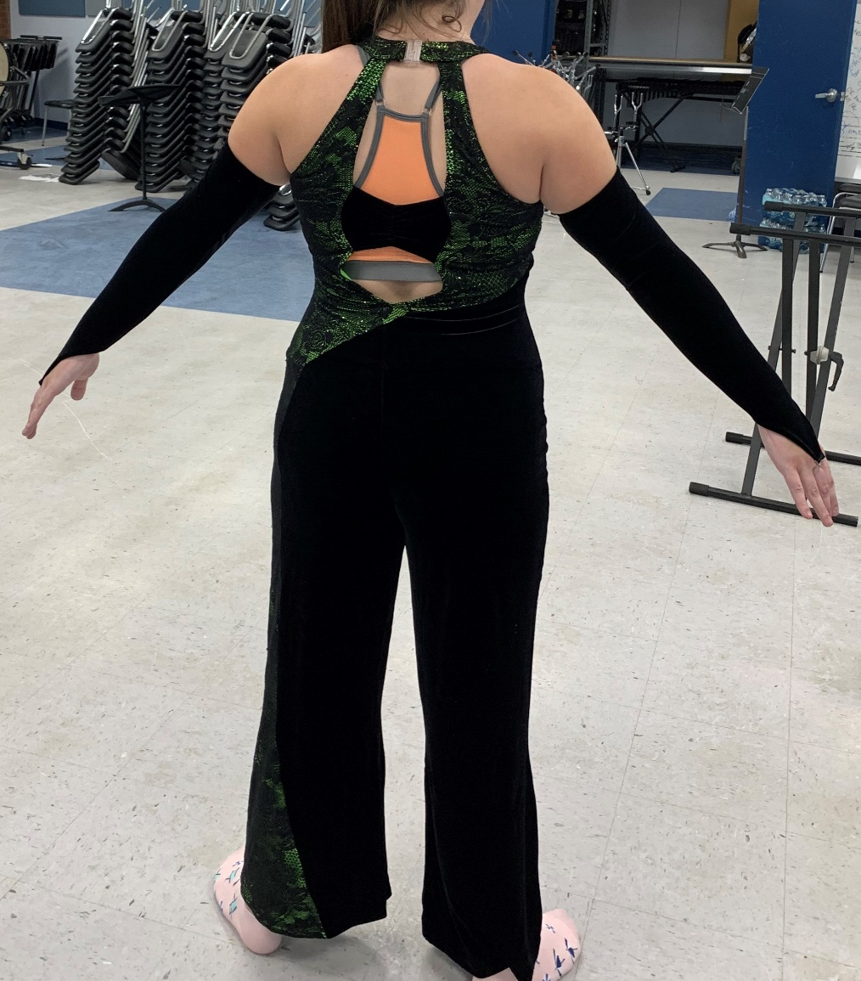
15 – Bugs with armbands
(5 medium, 6 large, 2 XL, 2 XXL)
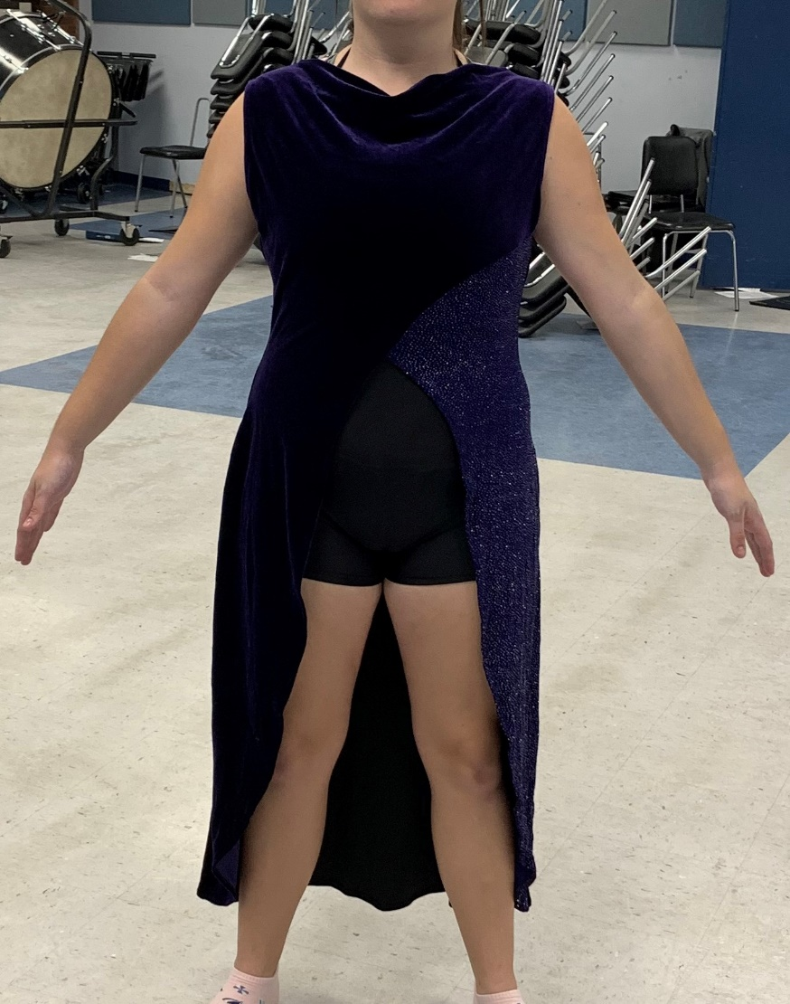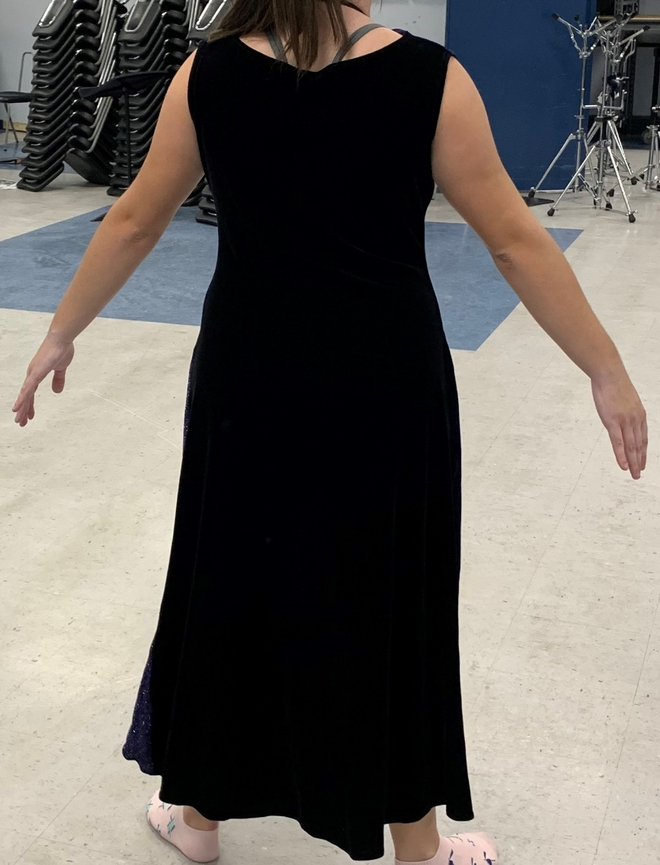

21 – Purple/Black (unitard not included)
(4 XS, 7 small, 5 medium, 2 large, 1 XL, 1 XXL, 1 XXXL)
1 large – all black (unitard not included)

11 – Opus (burgundy)
(1 small, 2 medium, 1 tall, 6 large, 1 male – 3 medium shorts, 5 large shorts)
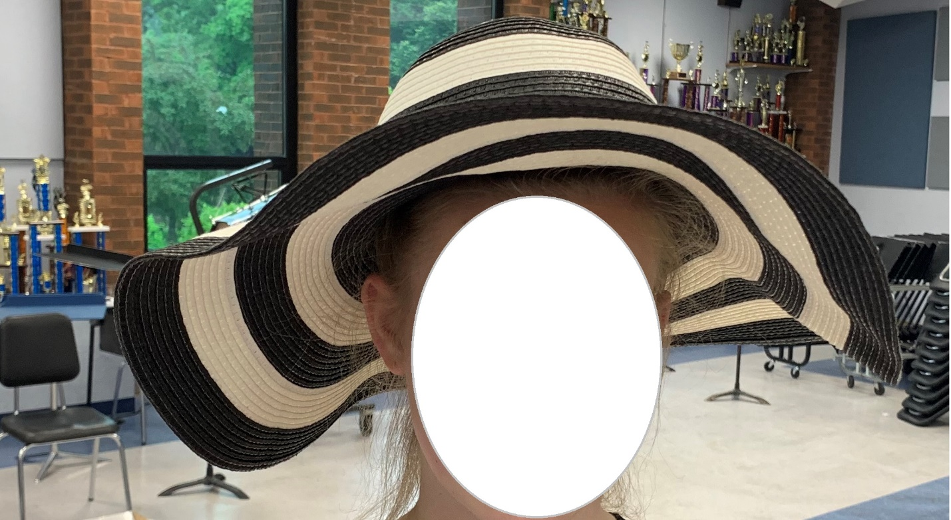
Audrey Hepburn hats - $10 each

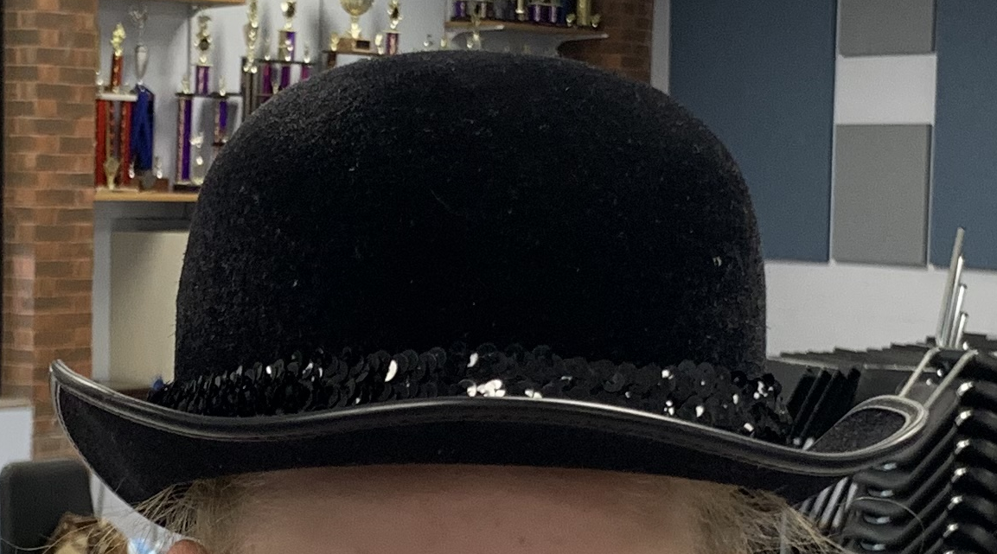
Bowler Hats

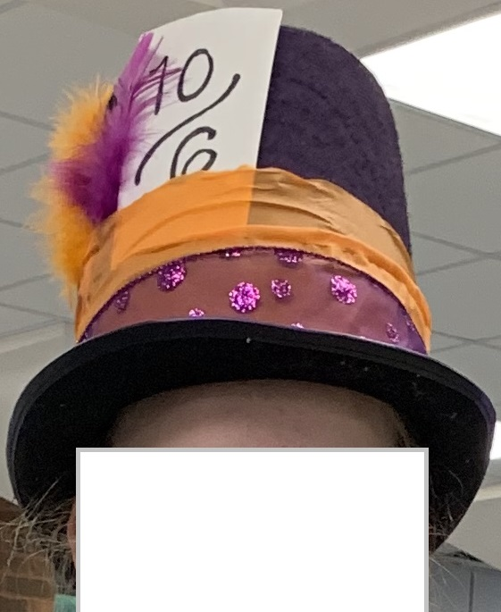
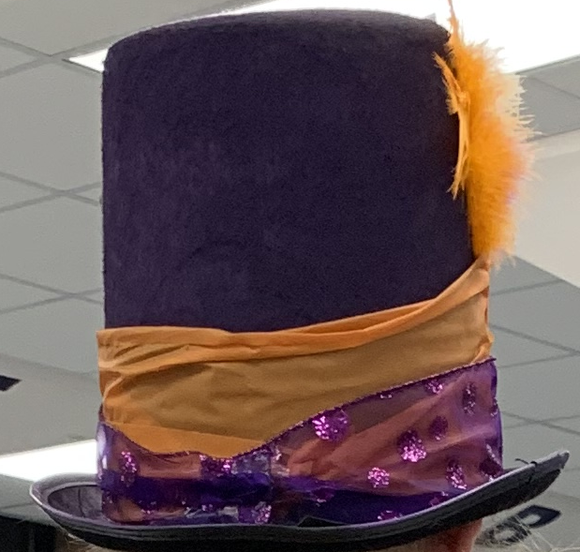
Mad Hats

PRACTICE FLAGS:

Practice – Charlie Brown flags (15 flags) --- No picture

Practice – Blue swing flags (29 flags – 33”x52”) --- No picture

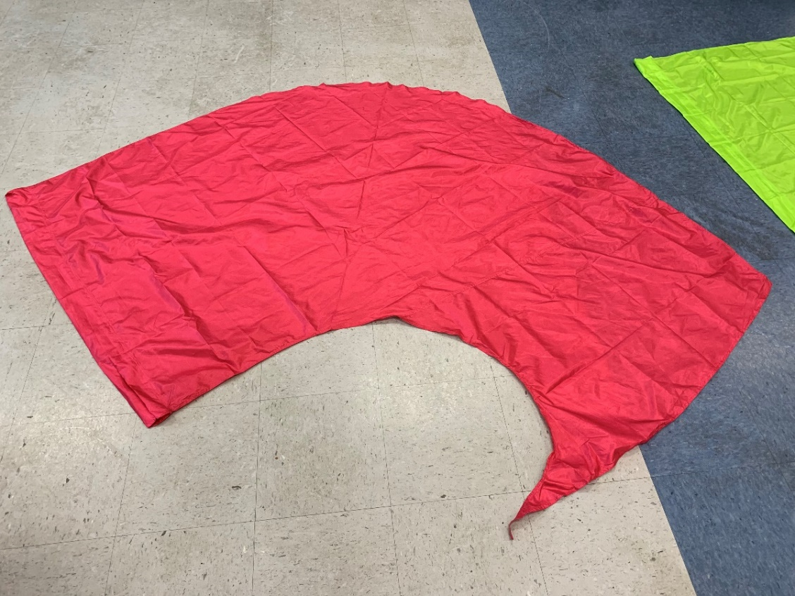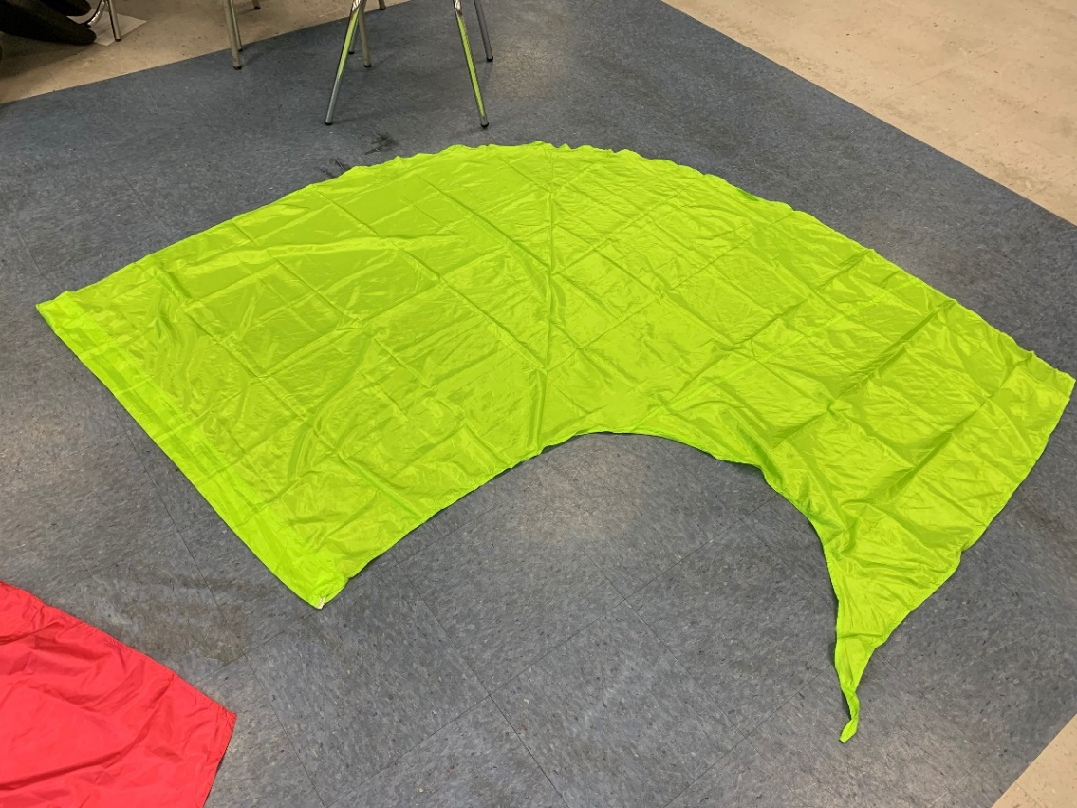
Practice – oversized swing flags
Pink (31 flags)
Green (22 flags)

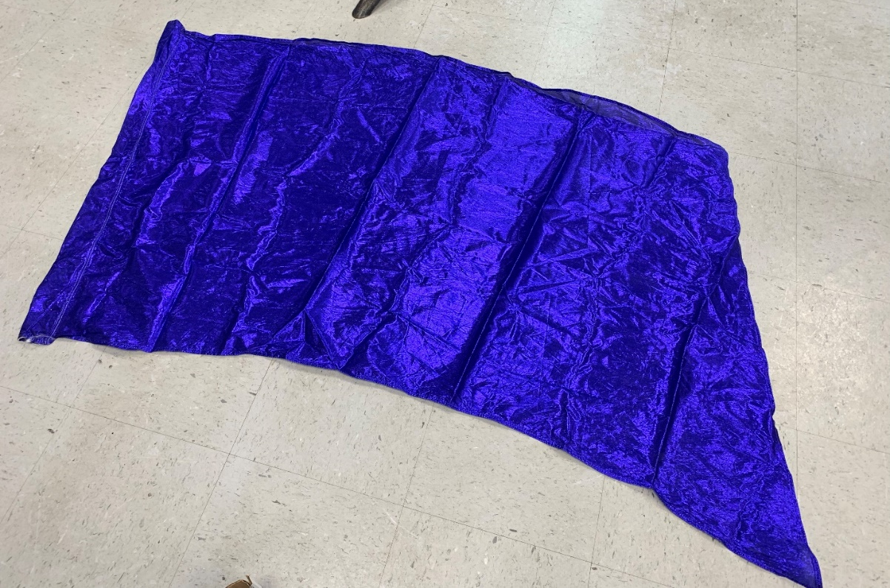
Practice – Shiny dark blue (2 flags – 35”x68”)

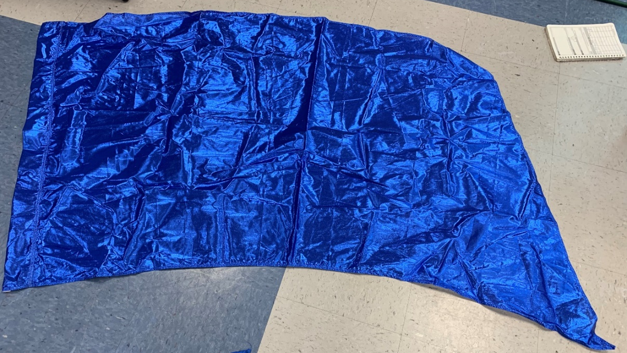
Practice – Shiny light blue (1 flags – 35”x68”)

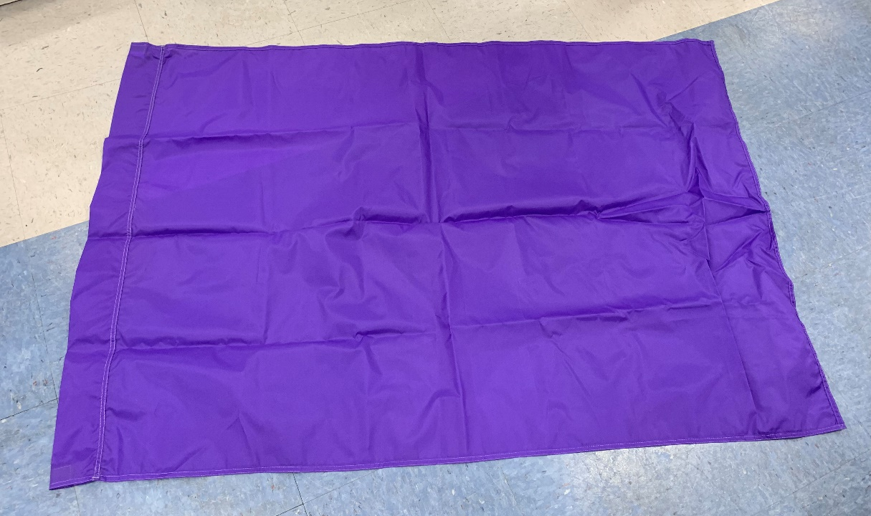
Practice – rectangular purple flags (16 still in pkg, 2 not in pkg – 35”x52”)

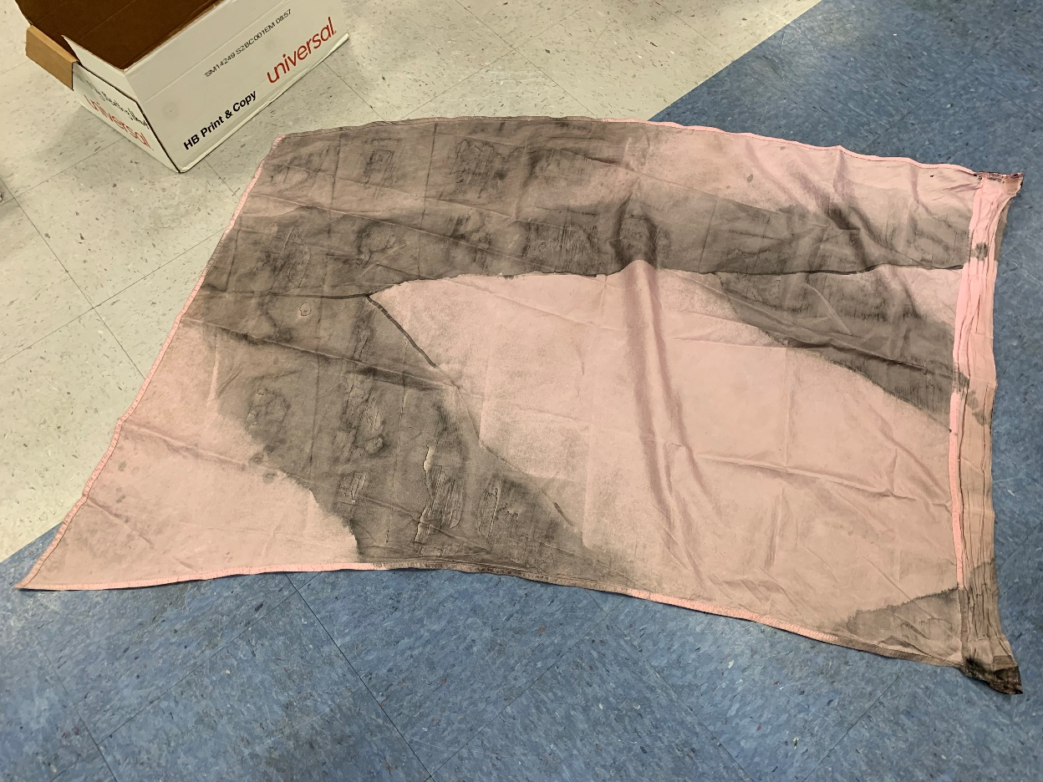
Practice – Pink flags (16 flags – 36”x52”)

